## ARDUINO BASED ALTERNATING CURRENT (AC) CONTROLLER SYTEM

**________________________________________________________________________**

A Capstone Project

Presented to the Faculty Members of the

College of Computing Studies, Information and Communication Technology

ISABELA STATE UNIVERSITY

Echague, Isabela

________________________________________________________________________

In Partial Fulfillment of the

Academic Requirements for the

Bachelor of Science in Information Technology (BSIT)

Networking and Security Track

**By:**

Oxales, Rayan C.

Batoon, Mary Gracel G.

## June 2022

# APPROVAL SHEET

The Capstone Project attached here in entitled: “ARDUINO-BASED ALTERNATING CURRENT (AC) CONTROLLER SYSTEM” prepared and presented by RAYAN C. OXALES and MARY GRACEL G. BATOON in partial fulfilment of the requirements for the degree of Bachelor of Science in Information Technology (BSIT), Networking and Security Track is hereby endorsed.

ADVISORY COMMITTEE

**JHAMIE TETZ INFANTE MATEO, MSIT, MDM, DM**

Project Adviser

PANEL COMMITTEE

**RENALYN G. TECSON, MSIT ROMERO DANTE C. SALUM, MIT**  Content Panel Technical Panel

**EDWARD B. PANGANIBAN, Ph. D.**

Panel Chairperson

Approved and accepted as a partial fulfillment of the requirements for the degree Bachelor of Science in Information Technology (BSIT), Networking and Security Track.

**RENALYN G. TECSON, MSIT** _____________________

BSIT, Program Chairperson Date

**CHRISTINE CHARMAINE G. SAN JOSE, DIT _____________________**

Dean, CCSICT Date

**MAYLENE E MANUZON**  **____________________**  University Registrar Date DEDICATION

The researchers would like to dedicate this capstone project to their friends, classmates, instructors, and ISU staff who stood by them and shared knowledge and ideas to make this study easier, more enjoyable, and possible to do. To their beloved parents, who have been the source of inspiration and strength when they thought of giving up, and who continually provide moral, spiritual, emotional, and financial support. Most of all to the Almighty God, who gave me energy, courage, and a positive mindset every day to make this study possible.

**THE RESEARCHERS**

## ACKNOWLEDGEMENT

The researchers would like to express their deepest gratitude and appreciation to all the people who have expressed their help in the completion and development of this study: To the ISU-Echague faculty staff, especially the registrar, admin staff, utility, and guards, for uplifting their morale during the times they were down; To their adviser, Dr. Jhamie Tetz Infante Mateo, for her invaluable ideas for reminding them from time-to-time to finish everything on time and for being a good critic and counselor from the start until they have finished the study. For her support and guidance in identifying and correcting errors in the project; To their subject adviser, Dr. Darios B. Alado, for his guidance, support, and reminding us to finish everything on time. To the panel members, Dr. Rhowell M. Dellosa, Dr. Romero Dante Salum, Renalyn G. Tecson, and Dr. Edward Panganiban for their assistance, on-point critiquing, insights, and remarks on the capstone project. To ISELCO 1, Engr. Virgillio L. Montano and Engr. Aldwin A. Macatbag for their guidance and support in the installation and testing of the device, as well as to all of the electrical engineers for their participation in the system evaluation and for providing ideas to complete this project. To their friends, Jayvee P. Farias, Wenalyn T. Dela Cruz, John Nichole R. Simon, and Ronnie Valenzuela, for the joys of being close to one another, and for the helping hands they have extended to one another

.

**THE RESEARCHERS**

# ABSTRACT

This study focused on the development of a user-friendly technology-based system to address the issues and concerns raised during the traditional cutting of electricity. The process of cutting electricity may take days or even weeks before they cut the electricity line, wherein it is timeconsuming and not safe for both consumers and line personnel. This project is only for Isabela I Electric Cooperative (ISELCO) 1. The main objective of this study is to provide an efficient way of cutting electricity by eliminating the manual tasks involved in disrupting the supply of electricity to a household when the bill due date has lapsed. The Arduino-Based Alternating Current Control System has the following features: remote device control; generating and printing consumer reports of disconnected and reconnected; responsive web application; real-time SMS notification; statistical report in graphical format; and record management.

The researchers used Rapid Application Development (RAD) to develop the project faster within the timeframe. The system was designed and developed using the Bootstrap Framework, which was utilized for the front-end, while at the back end of the system it was utilized using PHP and MySQL. This study utilized the ISO 25010 Software Product Quality Standard, particularly on the criteria of Functional Suitability, Usability, Reliability, Security, and Maintainability, in evaluating the system quality using an adopted questionnaire from Urera & Balahadia (2019).

In conclusion, the system was evaluated by the Electrical Engineers of Iselco 1, Clients and IT Experts and gave a grand mean of 4.46, which is equivalent to "Strongly Agree" and obtained. This indicates that the developed system aids the ISELCO user needs in disrupting the electricity of every household and lessens the time in the process of cutting the electric line. Hence, this means that the evaluation implies that the system satisfied the stated needs of its target endusers.

# **TABLE OF CONTENTS**

TITLE PAGE i

APPROVAL SHEET ii

DEDICATION iii ACKNOWLEDGMENT iv

ABSTRACT v

TABLE OF CONTENTS vi

LIST OF FIGURES ix

LIST OF TABLES xi

CHAPTER I. INTRODUCTION 1

1.1. Rationale of the Project 1

1.2. Project Highlights 2

1.3. Objectives of the Project 3

1.4. Scope and Delimitation of the Study 4

CHAPTER II. REVIEW OF RELATED LITERATURE AND STUDIES6

2.1. Related Literature 6

2.2. Related Studies 10

2.3 Conceptual Framework of the Study 12

CHAPTER III. METHODOLOGY14

3.1. Requirement Analysis 14

3.1.1. Causal Loop 14

3.1.2. Gannt Chart 16

3.1.2.Wireframe 17

3.2. Technical Background (Project Framework) 21

3.3. Disconnection and Reconnection Flow Chart 22

3.4. Data, Software and Hardware Specification 22

3.4.1. Data 22

3.4.2. Sofware 23

3.4.3 Hardware 24

3.5. Functional Decomposition Diagram 25

3.6. Data Flow Diagram 26

3.7. Entity relationship diagram 28

3.8. Systems Design 29

3.8.1 System Development Methodology 29

3.9. Development and Testing 30

3.9.1 Data Gathering Procedure 31

3.9.2. Data Analysis 31

1. 9.3Population of the Study 33
   1. Software Testing 33
   2. Implementation Plan 34

CHAPTER IV. RESULT AND DISCUSSION 35

* 1. Develop an Arduino Based System that control the electric line and notify the specific client for disconnection and reconnection. 35
  2. Developed a prototype that controls the connectivity of the household’s electric current.

36

* 1. Test the functionalities of the system for the: 40
  2. Evaluation Result (ISO 25010) 47

CHAPTER V. SUMMARY, CONCLUSIONS AND RECOMMENDATIONS 54

* 1. Summary 54
  2. Conclusions 55
  3. Recommendation 56

BIBLIOGRAPHY 57

APPENDICES 62

* + 1. Relevant Source Code Appendix
    2. Sample Input/Output/Report Appendix
    3. User’s Guide Appendix
    4. Other Relevant Documents Appendix
    5. Grammarian Certificate Appendix
    6. Gallery Appendix
    7. Evaluation Tools
    8. Curriculum Vitae
    9. Glossary

**LIST OF FIGURES**

Figure 1. Problem Analysis using the Causal Loop14

Figure 2. Gantt Chart of Activities 16

Figure 3. Login17

Figure 4. Dashboard17

Figure 5. Consumer18

Figure 6. New Consumer18

Figure 7. Report19

Figure 8. Logs19

Figure 9. Settings20

Figure 10. Systems Diagram/Project Framework21

Figure 11. Disconnection and Reconnection Flow Chart22

Figure 12. Functional Decomposition Diagram25

Figure 13. Data Flow Diagram of Administrator 26

Figure 14. Data Flow Diagram of Sub Administrator 27

Figure 15. Data Flow Diagram of Consumer Side27

Figure 16. ERD of the Database28

Figure 17. The Rapid Application Development (RAD) Diagram 29

Figure 18. ABACCS 35

Figure 19 (Hardware) Components of the Arduino-based Device Controller36

Figure 20. Wiring Diagram of the Arduino-based Device Controller37

Figure 21 Developed Prototype of ABACCS38

Figure 22. Installation and Testing of the System39

Figure 23. Login Page40

Figure 24. Dashboard41

Figure 25. Manage Consumer Page42

Figure 26. Consumer form 42

Figure 27. Manage Users Account 43

Figure 28. Users Form44

Figure 29. Send Connectivity Notice45

Figure 30. list of Consumer Report 45

Figure 31. Print Consumer Report 46

Figure 32. Receive Connectivity Notice47

# **LIST OF TABLES**

Table 1. Conceptual Framework13

Table 2. Software Requirements 23

Table 3. Hardware Requirements 24

Table 4. Likert scale32

Table 5. Respondents of the Study33

Table 6 Implementation Plan of the Study34

Table 7. Perception of the respondents in terms of Functional Suitability48

Table 8 Perception of the respondents in terms Usability49

Table 9 Perception of the respondents in terms in Reliability50

Table 10. Perception of the respondents in terms in Security 51

Table 11. Perception of the respondents in terms in Maintainability. 52

Table 12. Summary 53

## CHAPTER I

INTRODUCTION

### 1.1. Rationale of the Project

Every country in the world outlines its agenda to provide its stakeholders with the ability to acquire reasonably priced power and energy sources. The aim of which is to ensure cheaper power prices, a secure supply of power and a sustainable environment.

Since then, there has been a historic turn of events in terms of innovating the power and energy sector. In early 2010, Manila Electric Railroad and Light Company (Meralco) ventured on partnering with Philippine Long-Distance Telephone (PLDT) Company and San Miguel Corporation (SMC) to explore cost-efficient business opportunities. Today, Meralco has an improved online service using the Internet of Things (IoTs) like online applications, online viewing and reporting of outage maps, online management of clients’ bills, notifications, and electric service, and the most recent, their recent innovation called the Prepaid Electricity Service (KLoad).

During the phone interview with ISELCO-1 San Mateo personnel in May 2021, it was discussed that though they have already modernized their billing and collection system, the disconnection and reconnection process remains the same. When a particular household is due for disconnection, a line worker will manually cut the electrical flow from the meter reader, terminating the electricity from the distribution line or the transformer. In addition, these line personnel are on-call employees, which means their salary depends on how many households they disconnect and reconnect on a day.

However, on July 23, 2021, during a face-to-face interview with the President of Iselco 1, Alicia, and electrical engineers,The researcher discussed the study, which aims to develop a device that controls the amount of electricity used per household. During the interview, one of the electrical engineers suggested that the system device must use a contactor that will hold a high current voltage of electricity.

It is on this premise that this study aims to develop an innovative solution for the power and energy sector. This effort is also in response to Sustainable Development Goal (SDG) 7 (Affordable and Clean Energy), target 7-B, to expand and upgrade energy services for developing countries and SDG 8 (Decent Work and Economic Growth), target 8-8, to protect labor rights and promote safe working environments. Initially, the researchers seek insights from the electrical engineer from the local government unit if the project is feasible and the initial design of the project is doable. During the phone interview, the researchers are advised to consider the sizes of the cables and wires to be used.

In this case, the researchers developed an Arduino-based device that remotely controls via the web the electricity line of a household, entitled "ARDUINO-BASED

ALTERNATING CURRENT (AC) CONTROLLER SYSTEM". This innovation specifically helps ISELCO 1 in cost efficiency in terms of personnel services, reducing the risk of human life loss and health hazard, and reducing the cost of maintaining electrical lines. The researchers devised a feature that could notify the consumer through SMS notification of disconnection and reconnection. In addition, it has a feature that generates and prints reports of disconnection and reconnection of electric lines. The system also has a statistical report in graphical format to help in decision making. Finally, the system has a record management feature for the administrator to manage the list of consumers and control the consumer status. With these features, the system helps ISELCO 1 to eliminate the manual task of line personnel in disrupting supply electric lines in a household and to minimize the time-consuming process of cutting electric lines.

### 1.2. Project Highlights

The design and development of the Arduino-based Alternating Current (AC) Controller System is a web-based system that controls the electric line of a house hold.

The following are the highlights of the project:

1.2.1 Remote Control Device - Control the device by using a web application.

1.2.2 Responsive web application – Support such as tablet and mobile device

1.2.3 Generate and print consumer report of disconnected and reconnected

1.2.4 Real time SMS Notification – Notify the specific clients for disconnection and reconnection.

1.2.5 Statistical report in graphical format – Help ISELCO 1 for decision making.

1.2.6 Record management - admin can manage the list of consumers and control consumer status.

### 1.3. Objectives of the Project

This study aimed to design, develop and implement an innovative way on how

ISELCO-I manages its imposition of sanctions for their clients’ unpaid dues and eliminate the manual tasks in disrupting the supply of electricity to a household. Specifically, it seeks to:

1.3.1 Develop an Arduino Based System that control the electric line and notify the specific client for disconnection and reconnection.

1.3.2 Develop a prototype that controls the connectivity of the household’s electric current.

1.3.3 Test the functionalities of the system for the:

1.3.3.1 Administrator to:

1.3.3.1.1 Login to the system

1.3.3.1.2 View the total consumer and status of consumer statistics in graphical format

1.3.3.1.3 Manage consumer’s information

1.3.3.1.4 Manage user accounts

1.3.3.1.5 Send connectivity notice to the consumer through SMS

Notification

1.3.3.1.6 Print list of connected and disconnected consumers reports

1.3.3.2 Consumer to:

a. Receive connectivity notice through SMS Notification

1.3.4 Evaluate the user’s perception to the system quality using ISO 25010 Product Quality Standard with the following criteria:

1.3.4.1 Functional Suitability

1.3.4.2 Usability

1.3.4.3 Reliability

1.3.4.4 Security

1.3.4.5 Maintainability

### 1.4. Scope and Delimitation of the Study

This study focused on developing a prototype of an Arduino–based control system that will remotely disconnect and reconnect a subscriber's line connection in a given scenario when it undergoes testing by the experts. A contactor was installed before the fuse along with a relay, an Arduino Uno, and an Ethernet shield used for communication between the web-based system and the device.

The hardware device can accommodate one per household. Such activity was monitored within the control office of ISELCO-I. As soon as the bill reaches its due date, as their policy gives at least a maximum of three (3) days for a subscriber to settle their account, the admin module may opt to turn OFF the flow of electricity manually. Then the controller will manually turn ON the line connection. It will only be reconnected as soon as the billing division provides information to the line division that the account has been settled. Then the controller will manually turn ON the line.

During the first prototype where the researchers used a GSM module for the communication of the device and software, the researchers encountered technical issues such as incompatibility on the communication of the two GSM modules, inability to perform the program due to network signal and cannot meet the objective in terms of notifying the consumers account for the disconnection and reconnection. The 16-channel relay was a limited and it cannot hold 220 volts of electricity line per house hold. In addition, the data is not accurate and the Arduino Uno had a problem in terms on responding with the software command. The researchers used Ethernet Shield instead of using two GSM module.

However, the system will not operate if there’s no Internet in the area, so when the device is installed, there must be an accessible internet connection. The device will sourceout its power directly from the distribution post converted as direct current (DC) through a power jack of 7–12V via a USB connector of 5V. In terms of the information that will be used to make the device work, the web app was made to control how the hardware device connects and disconnects. In addition, the researchers prepared a cost-benefit analysis to identify the economic viability or feasibility of the study.

## CHAPTER II

REVIEW OF RELATED LITERATURE

This chapter introduces the related researches, related systems and conceptual framework on which this study is based.

### 2.1. Related Literature

This research aims to develop an innovation in the way ISELCO manages power lines, focusing on the imposition of sanctions for unpaid dues. When a client receives a disconnection notice, line personnel are usually tasked with going to the location and manually cutting the power supply by disconnecting the electric line from its source. The title, Arduino-Based Alternating Current (AC) Control System, refers to the study's attempt to eliminate manual tasks and use innovative methods of disrupting the supply of electricity to a household.

The smart grid concept was defined by Cecati (2014) as an electrical network that can intelligently integrate the actions of all participants connected to it, both generators and consumers, in order to efficiently provide a sustainable, economical, and safe power supply. The primary goal is to provide optimal information and load control to consumers, retailers, and network operators in order to reduce system requirements and costs while increasing energy efficiency.

This is a once-in-a-lifetime opportunity to lead the energy industry into a new era of dependability, availability, and efficiency that benefits both our economic and environmental health. During the transition period, tests, technological advancements, consumer education, and standards will be carried out, as well as regulation development and information sharing among projects, to ensure that the benefits we envision from the smart grid become a reality. The benefits of the smart grid include: (1) more efficient power transmission; (2) faster restoration of power after electrical outages; (3) lower operating and administrative costs for utilities, resulting in lower energy costs for consumers; (4) lower peak demand, which also helps lower electricity tariffs; (5) greater integration of large renewable energy systems; and (6) better integration of power generation systems between customers and owners.

According to The Smart Grid (2015), the potential benefits of the smart grid are generally discussed in terms of economic, national security, and renewable energy goals. It provides technical solutions to problems like inconvenience, power usage monitoring, and power theft. It is used in every aspect of the energy system, including generation, transmission, distribution, services, and consumption. As a result of the successful and widespread development of intelligent networks, countries can anticipate high-quality power supply service, improved system reliability, and service quality (Smart Grid Task Force, 2016).

The Internet of Things will underpin the next era of intelligent computing (IoT). Today, the Internet of Things (IoT) is critical in transforming "traditional technology" from home to office into "next generation computers everywhere." The "Internet of Things" (Weber, R.H., 2010) is gaining traction in research around the world, particularly in the field of modern wireless communication. The term "Internet of Things" (Suo et al., 2012) refers to tangible objects and their virtual representations in the Internet-like structure proposed in 1998.

The term "Internet of Things" (IoT) is made up of two words: internet and things. The term "things" in IoT refers to various IoT devices with distinct identities that enable remote sensing, actuation, and real-time monitoring. specific types of data IoT devices can also dynamically exchange data with other connected devices and applications, either directly or indirectly, or collect, process, and send data from other devices to various servers. The "Internet," on the other hand, is defined as a global communication network that connects billions of computers worldwide and allows information to be exchanged. According to several researchers, 50 billion IoT-based devices will be connected globally by 202. (Nayyar, 2016).

As Downets (2019) points out, the Internet of Things enables a new information supply chain by connecting people from various spectrums and monitoring events.

Intelligent devices with embedded technology can automatically collect information from shared resources (e.g., physical devices) and use it to provide new services to end users (J.Gubbi, R.Buyya, S.Marusic, M.Palaniswami, 2013). The Internet of Things integration provides a common configuration-based infrastructure for application and data source integration, data mapping and transformation as needed, and business logic orchestration to deliver composite services (Thompson, 2016).

The use of the Rapid Application Development (RAD) methodology This software development method emphasizes rapid prototyping and iteration to reduce development time while maintaining system quality. RAD focuses on gathering customer requirements through workshops or focus groups, and testing prototypes with customers early on using an iterative concept, reusing existing prototypes, continuous integration, and rapid delivery. A prototype is a functional model that corresponds to a component of the system that has been developed (Morse, 2016).

Simultaneously, functional modules are being developed in RAD as prototypes are integrated in order to speed up product processing and delivery. Changes resulting from user participation in development can be more easily integrated into the development process because there is only minimal detailed pre-planning (Tutorialspoint.com, 2017).

RAD development addresses the challenges of software development by creating systems faster, at a lower cost, and with higher quality. Users can visualize and request changes to the system as they build it with prototypes, allowing the application to evolve iteratively. The RAD method is also very effective. Systems are being developed when business needs are volatile or unusual.

Martin (1991) divides RAD as a method into four stages, also known as the RAD life cycle. The stages of the RAD life cycle are as follows: Phases of requirement planning, user design, construction, and cutover

A prototype is a design for a preliminary version of an item that will be built and tested. The phrase is derived from a Greek phrase that means "primitive form." Prototypes are widely used in design and engineering to perfect products and processes prior to largescale implementation. Automobile designers, for example, frequently build prototypes of the latest vehicles to test whether their concepts work in practice. It is also useful for presenting designs to company executives or buyers in order to persuade them to support a project (Prototype, 2015).

Floyd (1984) defines prototyping as a system that includes practical selection, construction, evaluation, and use. Capabilities that can be prototyped are chosen, and a prototype is built. This prototype is evaluated, and it is also used for outlining specifications or as part of the new device. Prototyping, according to Naumann and Jenkins (1982), is a four-step iterative process involving customers and developers: 1) The primary desires of the user are identified; 2) a running prototype is created; 3) the running prototype is then carried out and used; and 4) the prototyping device is revised and improved.

A prototype can also be a simple reflection of one part of a larger plan. It can also be used to create an item's appearance without its functionality, or the functionality without the appearance. A fully functional prototype is a full-scale operating version of the most recent product (Prototype, 2015).

Second, Ferdous et al(2019) .'s Design and Development of SMS-Based Prepaid Electricity Billing System Using GSM and Arduino inspired this study. This prototype made use of voltage, current, and strength, as well as a variety of gadgets and Arduinobased hardware. Cash is inserted into this device via the keypad and displayed on the LCD display. The primary goal of this research is to provide a low fee and flexible computerized payment for electricity billing devices. Because the most recent billing device has been discovered to be time-consuming.

### 2.2. Related Studies

Andie et al(2019) .'s study, titled "Web-based Smart Parking: IOT Microcontroller Studies," focuses on addressing the problem of vehicles in terms of parking space. Using the web and an ESP8266-based microcontroller, the system will inform prospective users about the parking location. Essentially, this system was designed to check the available parking location conditions on the fly, as well as calculate the number of cars passing through the parking gate and inform potential users of the parking lot. The following components were used to create the Smart Parking prototype: Wemos D1 R2, HC-SR04 Ultrasonic Sensor, PCB board, Laser Module, Sensor Light Dependent Resistor, and Adapter. As a result, this will assist in detecting parked cars and their locations, as well as providing a predetermined parking location.

Lestari (2018)'s "Application of Home Light Control System Using Arduino with Mobile Based WIFI Media" is another IoT study. A home or building equipped with integrated technology and tools, which can be a computer or other device. A smartphone, for example, is automatic and programmed to provide all comfort, safety, security, and energy savings. Furthermore, this system can be used to control almost all the equipment and equipment in the home, from lighting settings to various household appliances, which can only be done with sound, infrared light, or remote control.

Aside from controlling devices within the home, the internet of things can also control and monitor a wide range of things, such as traffic congestion. The study of AlMayouf et al. supported this implication (2018). This is an application designed to address one of the most serious issues confronting modern societies: traffic congestion. The application will provide an accident management system that will use VANETs in conjunction with cellular technology in public transportation. The provided system allows for real-time communication between vehicles, ambulances, hospitals, roadside units, and central servers. This system employs a multichip optimal forwarding algorithm to determine the best route between the source (accident vehicle) and the destination (ambulance). This can shorten the time it takes to notify an ambulance that it is needed at an accident scene. The research is divided into five sections: vehicular, central server, RSUs, ambulance, and hospital. This aided in the development of an accident management system that uses public transportation cellular systems and VANETs to enable efficient real-time communication between vehicles such as ambulances, hospitals, RSUs, and central servers.

Albatish et al. (2018) describe the design of a desktop-based intelligent tutoring system, which overcomes the difficulties encountered when working with the Arduino platform. The main idea behind this system is to provide a systematic introduction to the Arduino platform. The system displays Arduino circuit boards that can be purchased at a low cost or assembled from freely available plans, as well as an open-source development environment and library for writing code to control the Arduino platform's board topic. The system adapts to the individual progress of the trainee. The system acts as a special tutor, dealing with trainees based on their levels and skills. The system was evaluated using both professional and unprofessional trainees in this field, and the results were positive.

Essentially, the growth of the Internet of Things has aided certain accounts in monitoring and supporting various spectrums. As a result, IoT development typically employs Arduino as a prototyping tool. This system is both inexpensive and versatile in its application. This was implemented to control and monitor home appliances when the owner was not present, and this time the researchers used Arduino to control and monitor things within their personal parameters (David et al., 2015). Kumarkhaniya et al. (2019) conducted current research with an Arduino Uno and a motor driver and Bluetooth module.

Arduino, an open-source prototyping platform, is built on user-friendly hardware and software that makes use of the ATmega328 microcontroller. Since then, robotics has become an important part of our daily lives, as well as in the field of technology, and it has played an important role in the development of this is a very simple and easy type of remotecontrolled car, in which the ordinary microcontroller is powered by Arduino and the IR sensors have been replaced by a Bluetooth module. Any Android or iOS phone can be used as the remote control. This project can be carried out on a larger scale for real-time vehicles.

When configuring the prototype, tools other than Arduino may be assigned. This suggestion is supported by Nasution et al. (2017)'s Arduino-based study, "Prototype of Home Appliances Using GSM and Arduino Modules." The SIM900 GPRS/GSM module, Arduino, and a relay module were used in the research to create a prototype design. Essentially, this prototype uses Arduino, Relay, and GSM to control electrical devices.

According to research, it would help control electrical appliances to prevent fires in homes and facilities.

Because of the level of influence on both construction and product acceptance, the ISO 25010 standard evaluation as instruments for software development can be used, and its aspects of user communities should be considered as a high-level attribute (Miguel, Mauricio, & Rodrguez, 2014). In the opinion and perspective of individual respondents, the ISO 25010 standard model can be used to establish a baseline vocabulary for managing software product quality. They do, however, require best practices to elicit, specify, analyze, and validate quality requirements while keeping in mind their limited resources. More research is needed on effective practices to improve the process and the provision of specific practices to improve specific product quality characteristics (Alberto, GarcaMireles, 2016). This model guided the methodology used to evaluate the system in this study.

The ISO 25010 standard evaluation as instruments for software development can be utilized and its aspects of user communities should be considered as a high-level attribute because of the level of influence on both construction and product acceptance (Miguel, Mauricio, & Rodríguez, 2014). The ISO 25010 standard model can be used to establish a baseline vocabulary for managing software product quality in the opinion and perspective of individual respondents. However, they need practices with which to elicit, specify, analyze, and validate quality requirements that consider their limited resources. Effective practices to improve the process and the provision of specific practices to enhance specific product quality characteristics need further research (Alberto, García-Mireles, 2016). This model served as a guide to the methodology in evaluating the system in this study.

### 2.3. Conceptual Framework of the Study

The figure below illustrates the conceptual framework of the study. This concept was formed based on the literature and studies cited in this chapter.



*Figure 1. Input*



*-*



*Process*



*-*



*Output (IPO)*

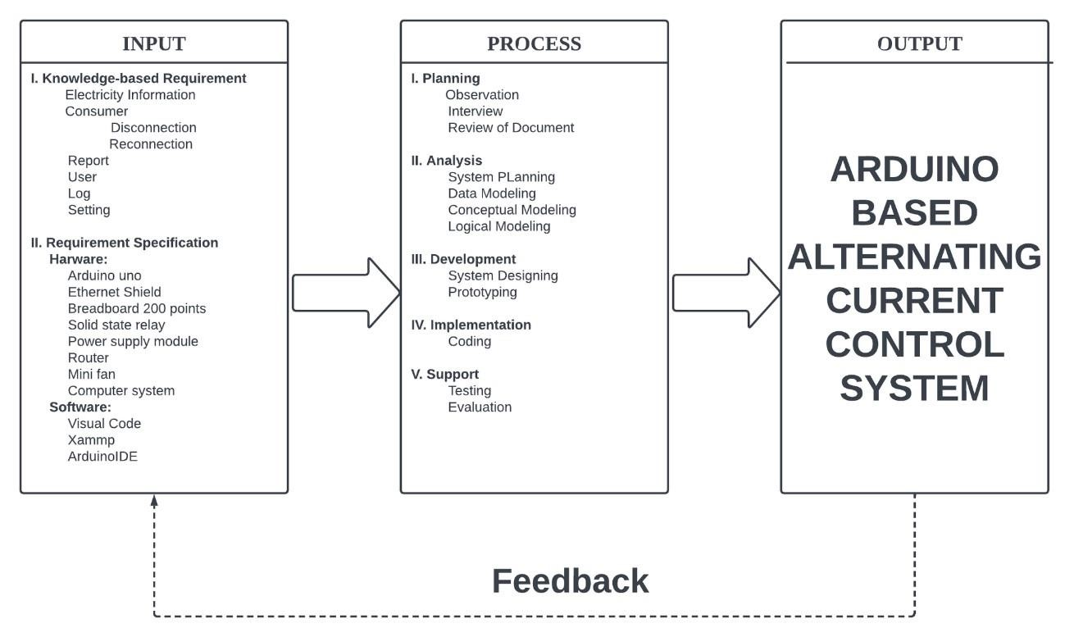

The given Conceptual Framework as shown in table 1. This prototype of the system required input such as knowledge-based information particularly on electricity and how it is being managed. Specific hardware and software as shown on the framework must be made available. after developing the system, it will employ the PADIS method of software development to produce the Arduino-Based AC Control System.

## CHAPTER III

METHODOLOGY

This chapter presents the processes and procedures required in the realization of this study using Planning, Analysis, Design, Implementation and Sustainability (PADIS) method.

### 3.1. Requirement Analysis

#### 3.1.1. Causal Loop

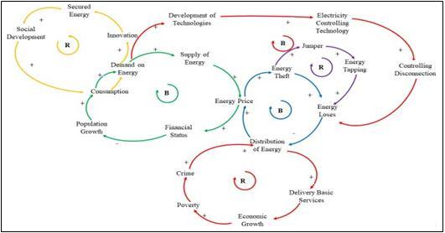

## Figure 2. Problem Analysis using the Causal Loop

Figure 2 illustrates the analysis to determine the main problem of the project, which is explained in every loop. The first loop explains the prevalent issue in society: population growth, along with its reinforcing variables. There is a direct proportional relationship between population growth and energy consumption. Microeconomics says that when there is an increase in the demand for energy, the energy supply will also rise. Since there needs to be more energy, the price will go up because more people are willing to make the product.

Since the energy price is reinforced, the second loop will show the variables along with the increased energy price. Elevated energy prices will be assumed to give a greater possibility for energy theft since electricity is a necessity for living. According to prevalent energy theft, there will be a large energy loss for the supplier since the consumed energy is bought according to the ratio of electricity subscribers. The prevalent rotational brownouts in some cities and municipalities all over the country are a sign of the electricity crisis. Because this crisis will directly affect several industries, manufacturing companies, and establishments, it will eventually result in a price increase for products such as electricity.

The third loop explains the correlation of energy theft and other variables that result in energy losses. The greater possibility for energy theft, which includes "jumper" in the electric lines, direct hooking, attack on electronic meters, injecting foreign elements into the meters and others, will lead to energy losses.

Another loop explains the relationship between the fluctuating distribution of energy towards different factors and variables. First, its bond towards the delivery of basic services. Unstable energy distribution will hamper the delivery of basic services. For instance, the affected manufacturing establishments will be hindered from providing faster services because of the unstable supply of energy. Since large companies cannot supplement faster delivery of basic services, the economic activity within the locality will diminish. Declining economic status will lead to poverty. The study shows that the economic status of the settlers will affect the financial capability of the settlers and will lead to poverty, which in turn will also reinforce the proliferation of crime.

The fifth loop explains the variables affecting higher demand for energy. As innovation increases, the demand for electricity also increases. Since there are several innovations in technology, it is anticipated that there will be greater energy security. Secured energy will lead to elevated social development because communication mediums will be faster and easier. Higher consumption results in a higher demand for electricity.

The result of the enormous demand for electricity is an increase in price. Consumers will also be required to pay higher liabilities. Subsequently, it will result in an increased number of disconnection notices because bills will not be settled on time due to higher prices. This activity is tantamount to a loss of energy.

23

23

The last loop explains the relationship between innovation and the resolution of the issue. Reinforcement of innovation will lead to the development of technologies. Consequently, technological progress will focus on energy-controlling devices that will lessen or address energy losses**.**

### 3.1.2. Gantt Chart

**Table 1.** Gantt Chart

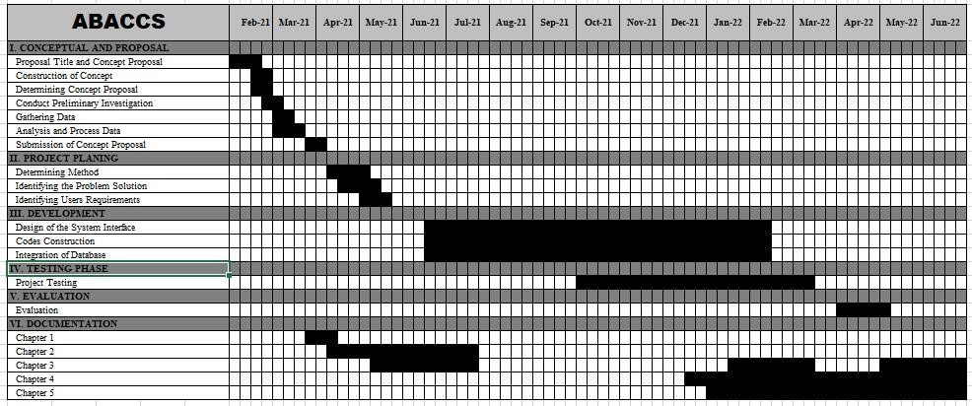

### 3.1.3. Wireframe

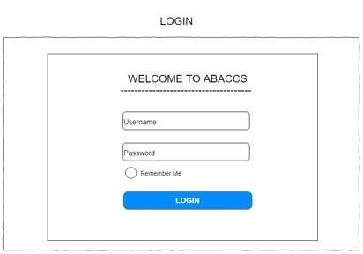

## Figure 3. Login

Figure 3 shows the login form. This form contains a field for the username and another for the password. When the login form is submitted, its underlying code checks if the credentials are authentic, giving the user access to the restricted page.

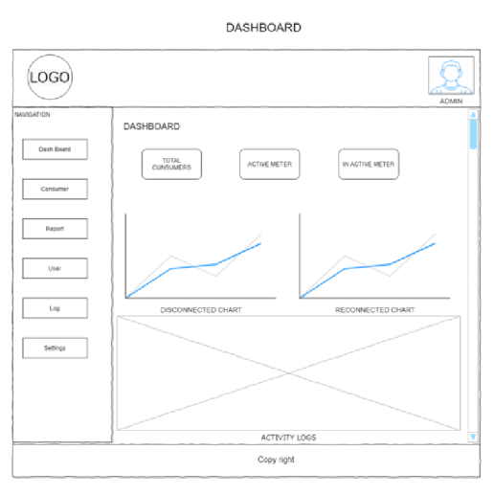

## Figure 4. Dashboard

Figure 4 shows the Dashboard module. This form contains a navigation bar, a graph, total consumers, and total active and inactive meters.

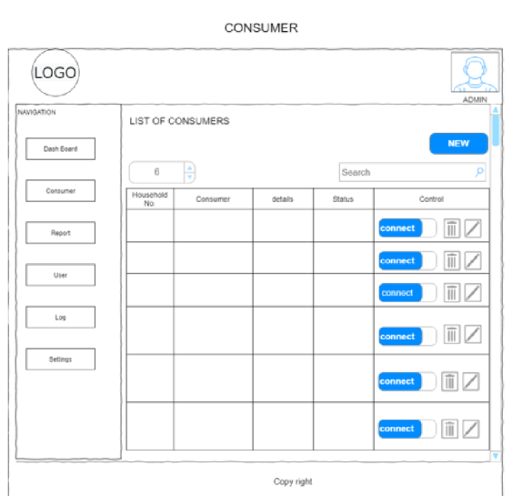

## Figure 5. Consumer

Figure 5 shows the consumer module. This form contains the basic information of a consumer and is where the administrator can control the status of the consumer.

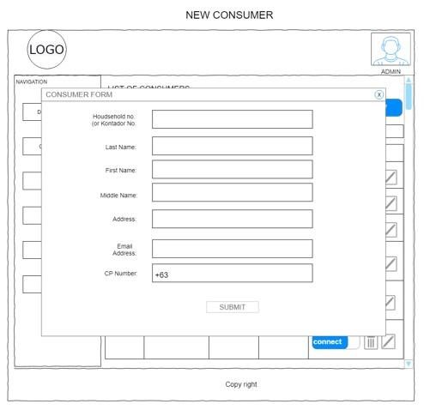

## Figure 6. New Consumer

Figure 6 shows the consumer form. It contains the basic information of a consumer, such as last name, middle name, first name, address, email address, and CP number



.

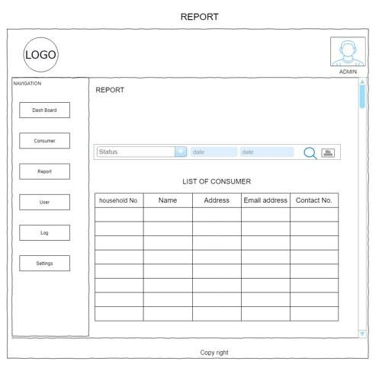

## Figure 7. Report

Figure 7 shows the report module. This form provides a list report of disconnections and reconnections.

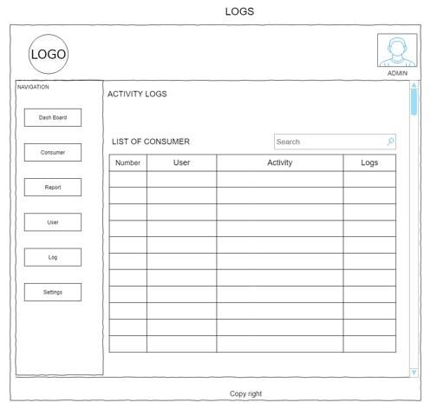

## Figure 8. Logs

Figure 8 shows the Logs Module. This module allows the user to view the list of activities of the users.

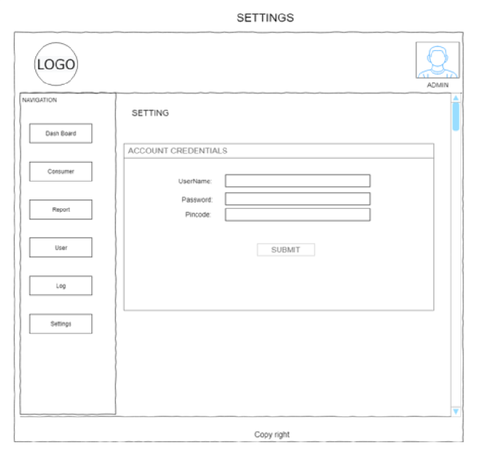

## Figure 9. Settings

Figure 9 shows the setting module. This module contains an account credential form where the user can change the username, password, and pin code.

3.2

. Technical Background (Project Framework)

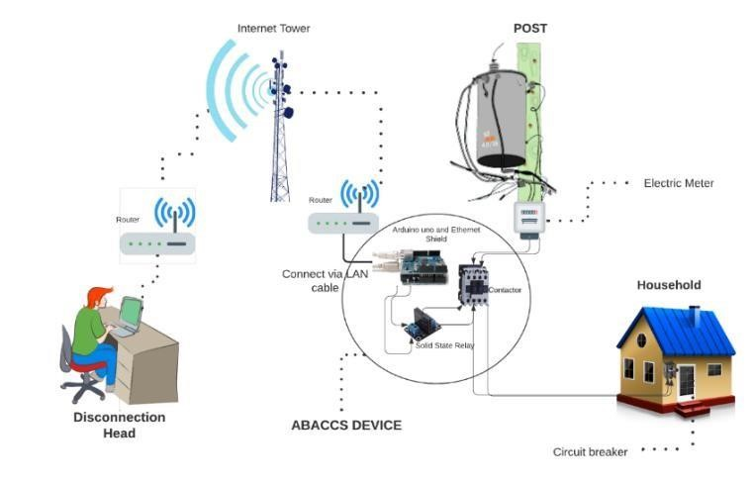

*Figure 10. Systems Diagram/Project Framework*

The developed project, ABACCS: Arduino-based Alternating Current (AC) Controller System, is a web-based application that is uploaded on the web server to control the supply of electricity for a household. As shown in figure 10, the developed system has two (2) users: a) the Administrator and b) the Sub-administrator. Using the URL created when the system was uploaded to the server, the two (2) users can access the system using their own assigned username and password. The disconnection head of ISELCO 1, who serves as the administrator of the system, can manage the information of all the users and consumers and can add users and consumers to the system. The administrator is responsible for monitoring and controlling the consumer's status for disconnection and reconnection and notifying the consumer through SMS. The administration can view the list of consumer status in disconnection and reconnection. All the data that the system can manage is stored in the web server’s database along with the system.

3.3

. Disconnection and Reconnection Flow Chart

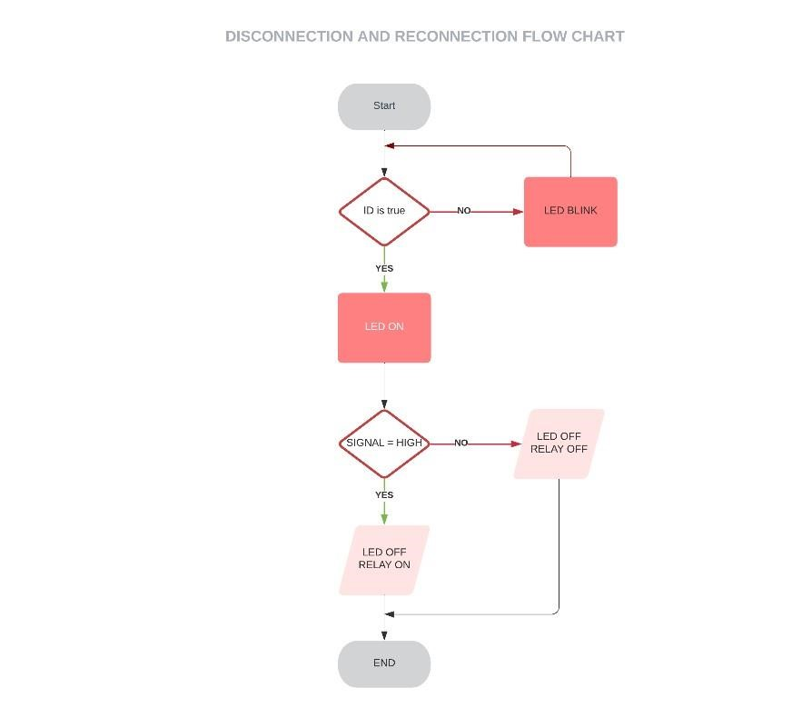

*Figure 11. Disconnection and Reconnection Flow Chart*

Figure 11 shows the disconnection and reconnection flow chart of the system. The administrator can make a decision to disconnect and reconnect the specific consumer. If the condition is true, the device will disconnect or reconnect, while if the condition is false, there will be no execution.

### 3.4. Data, Software and Hardware Specification

#### 3.4.1. Data

Administrator:

* admin Log-in o consumer information o mange users o report Sub-Administrator:
* Sub-admin Log-in o

Consumer information o

Report

#### 3.4.2. Software

**Table 2**. Software Requirements

|  |  |
| --- | --- |
| Software | Description |
| OS  Windows 10 | Researcher used this operating system (OS) is the program that, after being initially loaded into the computer by a boot program, manages all of the other application programs in a computer. |
| Visual Code | Researcher used this source code editor with powerful developer tooling to code in any programming language, without switching editors that is because can support many languages for developing of this system. |
| XAMPP | Researchers used this open-source cross platform web server to support for PHP development that provides a graphical interface for SQL. |
| Arduino  IDE | Researcher used this open-source software, which is used to write and upload code to the Arduino boards. The IDE application is suitable for different operating systems such as Windows, Mac OS X, and Linux. It supports the programming languages C and C++ |
| MySQL | Researchers used this open-source relational database management system which the SQLyog - MySQL GUI with a minimum requirement of at least  512MB of RAM, in order to store, process and request data. |

Table 2 shows the list of devices and software specifications used to make the devices compatible with accessing the project by the researchers.

#### 3.4.3. Hardware

**Table 3.** Hardware Requirements

|  |  |  |
| --- | --- | --- |
| Device/s |  | Hardware’s |
| Abaccs  Device | o o | Relay - A 12 volts solid state relay it used to give signal to contactor to on and off.  Arduino Uno - A device that is a low-cost, flexible, and easyto-use programmable open-source microcontroller board that can be integrated into a variety of electronic projects |
|  | o | Ethernet Shield – A device that used to connect the hardware into the web application. The Arduino Ethernet Shield allows an Arduino board to connect to the internet. |
|  | o | Contactor- A device used to on and off that can hold 220volts of electricity.A Contactors are used to control electric motors, lighting, heating, capacitor banks, thermal evaporators, and other electrical loads. |
|  | o | 12 volts Adaptor- it is used to power supply of the device. |
|  | o | 3-way splatters- it is used to minimize the connection of the other devices. |
| Personal  Computer  Laptop | o Processor: Intel Pentium, 1.6 Ghz o Memory: Kingston Memory 4GB o HDD: 500 GB Hard Drive o Monitor: 15 inches o Keyboard and Mouse | |
| Smartphone  Tablet/iPad | * RAM: 8GB Ram * Processor: Snapdragon 385 o Camera o 128 GB Storage o Wi-Fi o Mobile data * Battery: Li-Ion 2730 mwah, non-removable | |

Table 3 shows the list of devices used and Hardware Specification that made the devices compatible to access the project by the researchers.

### 3.5. Functional Decomposition Diagram

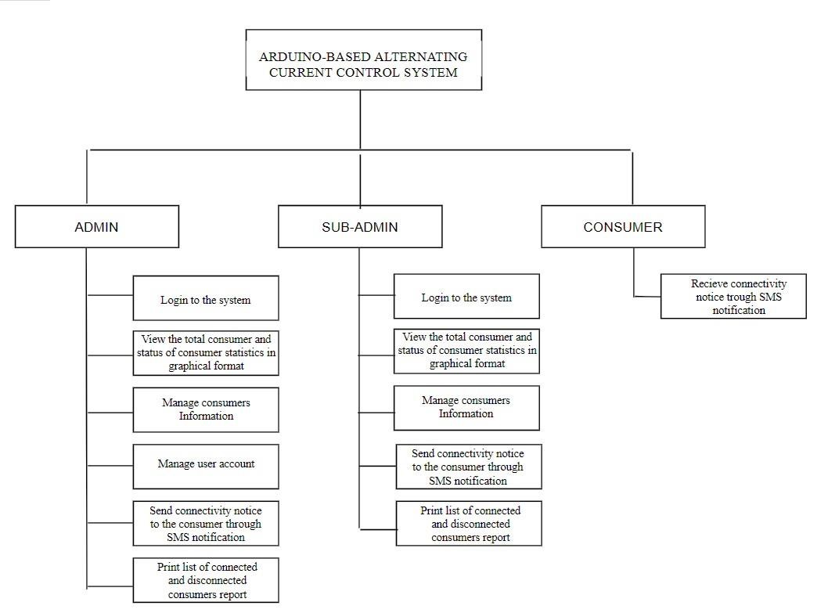

*Figure 12. Functional Decomposition Diagram*

Figure 12 shows the different functionalities of the system. The system provides two (2) users: The Disconnection head of Iselco1 serves as administrator and subadministrator. The system provides six (6) functionalities for the administrator and subadministrator side, such as Log-in, View list of consumers with their status, Consumer Management Information, Send SMS Notification, Print Reports. while the consumer side received the connectivity.

### 3.6. Data Flow Diagram

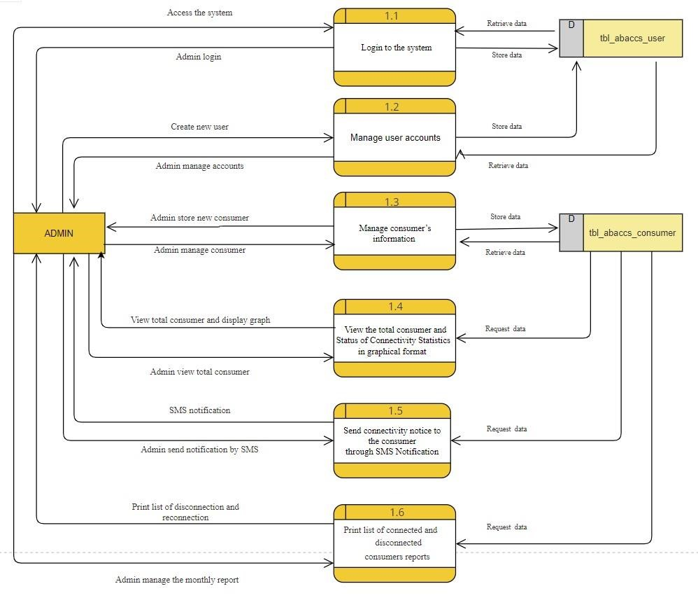

## Figure 13. Data Flow Diagram of Administrator

Figure 13 shows the data flow diagram of the administrator side of the system. The administrator manages the user account by adding the username, password, and pin code.

The administrator is responsible for managing the consumer’s information. The administrator has the ability to view the list of consumers and control the consumer status for disconnection and reconnection. This sends a connectivity status notice to the consumer through SMS notification. Lastly, the admin can print the list of connected and disconnected consumers' reports.



l

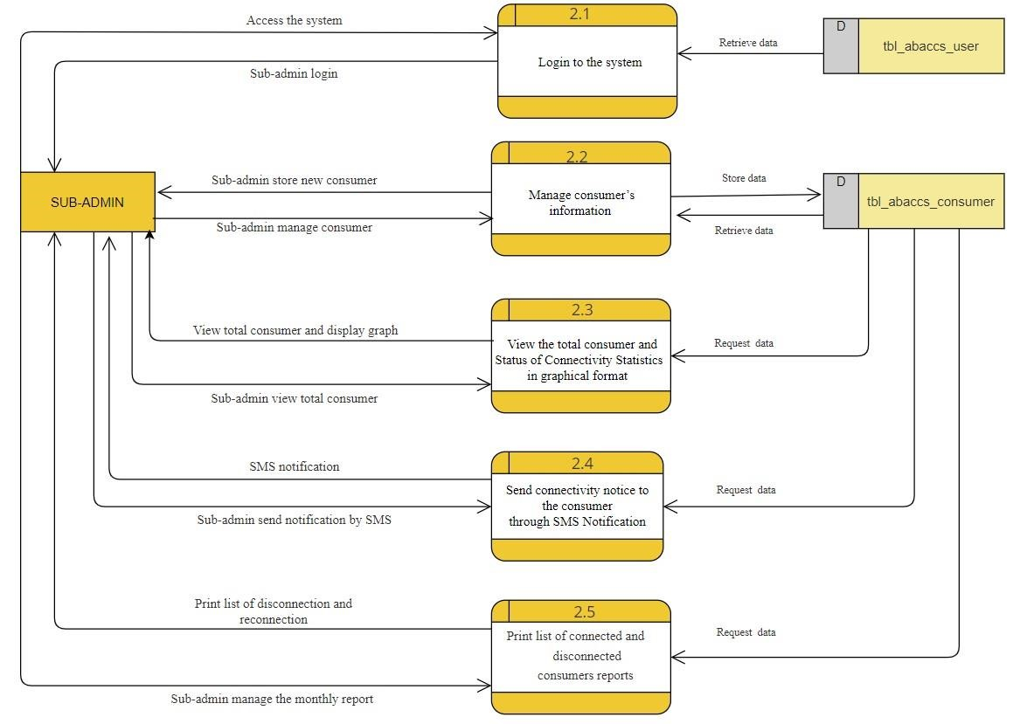

## Figure 14. Data Flow Diagram of Sub Administrator

Figure 14 shows the data flow diagram of the sub administrator side of the system into which you log in by entering your username and password. The sub administrator can manage the consumer’s information. The sub administrator has the ability to view the list of consumers and control the consumer status for disconnection and reconnection. This sends a connectivity status notice to the consumer through SMS notification. Lastly, the sub admin can print the list of connected and disconnected consumers' reports.

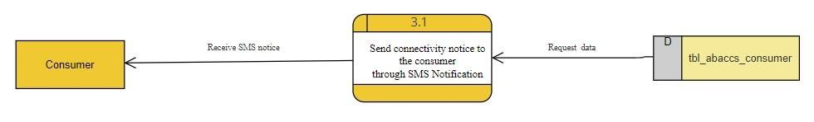

## Figure 15. Data Flow Diagram of Consumer Side

Figure 15 shows the data flow diagram of the consumer side of the system where the consumer receives the connectivity notice through SMS notification.

### 3.7. Entity relationship diagram



*Figure 16. ERD of the Database*

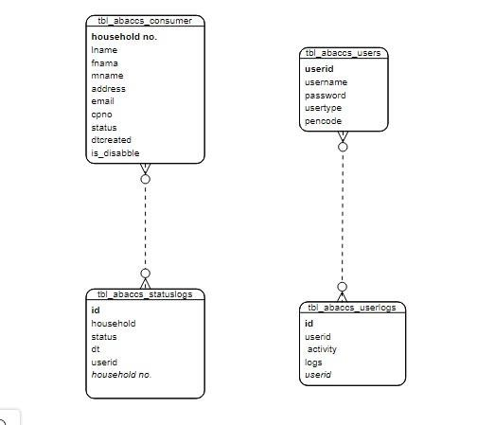

Figure 16 above illustrates the database design and table relationships of the system.

As shown in the diagram, the system will have four (4) tables, namely:

‘tbl_abaccs_consumer’, ‘tbl_abaccs_statuslog’, ‘tbl_abaccs_user’, and

‘tbl_abaccs_userlog’.

The ABACCS database table ‘tbl_abaccs_consumer’ stores the basic information about the consumer while the table ‘tbl_abaccs_statuslog’ stores the update status of the consumer. Table ‘tbl_abaccs_user’ stores the account credentials of the users and table ‘tbl_abaccs_userlog’ stores the user activity.

### 3.8. Systems Design

#### 3.8.1. System Development Methodology

This study utilized the Rapid Application Development (RAD) in creating a prototype:

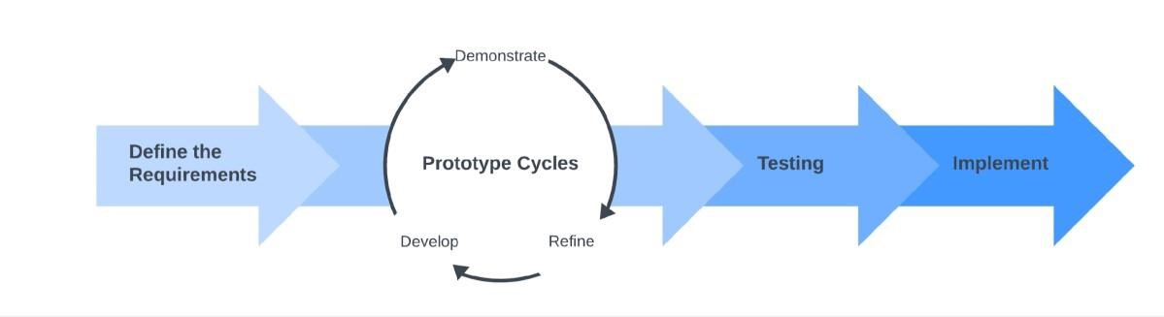

## Figure 17. The Rapid Application Development (RAD) Diagram

Phase 1: Define the requirements

This is where rapid application development sets itself apart from traditional software development models. This step involved the planning and analysis process. The researchers weren’t required to sit with the end users and get a detailed list of specifications; instead, they asked for a broad requirement. The comprehensive nature of the conditions helps to define specific needs at different points in the development cycle.

Phase 2: Prototype Cycles

This stage is where the actual prototyping cycle of development occurs. As the researchers followed a strict set of requirements, the researchers created a prototype, which was then presented to the IT experts of ISELCO-I who decided what they liked and what they did not like about the system. A series of refinements through the conduct of assessments will also be made.

Moreover, the researchers incorporate all the planned development and system testing procedures into the project. The system was designed and developed based on the identified functional requirements. Every developed module or functionality of the system was demonstrated to each member of the group and they evaluated it. In the event of a refinement or revision, enhancements are made, until all functional requirements are complete. The coding, module and integration testing for all the functionalities of the system were performed in this phase.

Phase 3: Testing

In this stage, a series of tests were conducted by the researchers to get feedback on what is good, what’s not, what works, and what does not get shared. Feedback based on the test conducted isn’t limited to just pure functionality, but also visuals and interfaces. Prototyping continues with all the stakeholders' feedback in mind. These two steps were repeated until a final product was realized that fit both the researchers’ and the client’s requirements.

Phase 4: Implement

It is the stage where the features, functions, aesthetics, and interface of the software are finalized with the client for final implementation, which includes deployment. Stability, usability, and maintainability are of paramount importance before delivering to the client.

### 3.9. Development and Testing

In developing the system, first, the system functionality was planned. Then, the interface circuits were designed, built one by one. The first interface that was designed is the connection between the mock billing system and the GSMC, followed by the Arduino Uno and the relay. Second, a mock billing system was developed together with the source code for the Arduino Uno.

After that, all the requirements will be built together to form a prototype. Once that is done, testing of the prototype comes next. The troubleshooting process was planned to be conducted repeatedly until the system works well, and meets the requirements. Lastly, repeated testing, re-designing, and re-building were done until it was accepted during the alpha testing. The results were evaluated during the beta testing.

#### 3.9.1 Data Gathering Procedure

To gather as much data as possible to utilize in the study, first a phone interview was done with an official of ISELCO-I to validate if there is such technology being used in this study.

Second, Internet techniques were employed by reading all related materials and, lastly, examining the websites of the existing IPPs for their products and services.

The researchers used questionnaire methods adopted from the ISO 25010 Product Quality Standard questionnaire to determine the feedback of the target clients on the developed system. The system evaluation questionnaire was based on ISO 25010, the degree to which the system satisfies the stated and implied needs of its end-users, and consisted of the following components: functional suitability, usability, reliability, security, and maintainability. Urera & Balahadia (2019).

#### 3.9.2 Data Analysis

To validate the output of this study, the ISO 25010 Product Quality Standard questionnaire was utilized.

The system was evaluated with the aid of IT experts, clients and electrical engineers from ISELCO 1, Alicia Isabela. Researchers applied the Likert scale to determine, compare, and supply remarks to the system.

**Table 4.** Likert scale

|  |  |  |
| --- | --- | --- |
| **SCALE** | **RATING** | **QUALITATIVE RATING** |
| 5 | 4.20 – 5.00 | Strongly Agree |
| 4 | 3.40 – 4.19 | Agree |
| 3 | 2.60 – 3.39 | Undecided |
| 2 | 1.80 – 2.59 | Disagree |
| 1 | 1.00 – 1.79 | Strong Disagree |

Table 2 shows the conversion of rating that the researchers used in tabulating the final result of the gathered data.

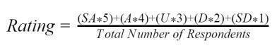

Where:

Rating = Total result of evaluation

SA = Total number of respondents who answered strongly agree.

A = Total number of respondents who answered agree.

U = Total number of respondents who answered undecided.

D = Total number of respondents who answered disagree.

SD = Total number of respondents who answered strongly disagree.

#### 3.9.3 Population of the Study

**Table 5.** Respondents of the Study

|  |  |  |
| --- | --- | --- |
| **TYPES OF RESPONDENTS** | **Total Number** | **Percentage** |
| ISU IT Experts | **3** | 15% |
| ISELCO 1 Electrical Engineers | **3** | 15% |
| Clients | **14** | 70% |
| **TOTAL** | **20** | **100%** |

Table 3 shows the respondents of the study. The respondents were divided into the three target groups of users. The system was developed to control the line of electricity that can be used by ISELCO 1, and the researcher obtained a total of 20 evaluators from endusers, broken down as follows: Three (3) electrical engineers, three (3) IT experts, and fourteen (14) clients. The IT expert and clients were added as the evaluators to validate the technical system.

### 3.9 Software Testing

System testing is a level of testing that validates the complete and fully integrated software product. The purpose of a system test is to evaluate the end-to-end system specifications.

URL Manipulation using HTTP

The researcher used this type of testing to determine the vulnerability of the database records and did not access any other vital information on the website by unauthorized users.

Technically, the researchers were limited to developing a website application rather than using the actual system of ISELCO-I. When the website application is made, it will have a module for disconnecting and reconnecting. This module's functionality will be tested directly on the developed prototype for the flow of power from the transmission lines.

### 3.11. Implementation Plan

**Table 6.** Implementation Plan of the Study

|  |  |  |  |
| --- | --- | --- | --- |
| **STRATEGY** | **ACTIVITIES** | **PERSON’S** **INVOLVED** | **DURATION** |
| Project Delivery | Uploaded the system to  the web server | Researchers and administrator (ISELCO  1) | 2 weeks |
| System’s  Installation | Installed and tested the system and required software and hardware | Researchers and administrator  (Electrical Engineer of  ISELCO 1) | 1 month |
| Users Training | Conducted Training with the targeted users of the system | Researchers, Clients,  Electrical Engineer and  IT Expert | 1 month |
| Project Review | Gathered feedback and system evaluation | Researchers, Engineer of ISELCO 1 and IT Expert | 2 weeks |

Table 4 shows the step-by-step process implementation plan of activities after the system has been developed. The researchers managed to deploy the developed system through a free web server for remote user testing, pilot testing, and evaluation. The system was able to be used by the different target clients, specifically the electrical engineers as well as IT experts in the field of web development.

## CHAPTER IV

RESULT AND DISCUSSIONS

This chapter presents the outcome obtained by the researchers in order to meet the project’s objective. The screenshot of the designed and created application and the documentation of the developed prototype, as well as the result of the objective to evaluate the user’s acceptance of the system functionalities using the ISO 25010 Software Product Quality Standard, are shown below.

**4.1 Develop an Arduino Based System that controls the electric line and notify the specific client for disconnection and reconnection.**

The objective of this project is to develop an Arduino-Based Alternating Current Controller System (ABACCS): a web-based system that controls the electric line and notifies the specific clients for disconnection and reconnection. This platform was created to eliminate the manual task of line personnel in disrupting a household's electricity supply. There are two users in the system: the administrator and the sub-administrator. The front end of the system was designed using the Bootstrap framework, while the system back end was designed using a combination of PHP and MySQL. These web development tools helped the researchers to design and develop the system’s user-friendly features to be effectively used by the target end-user.



*‘i*

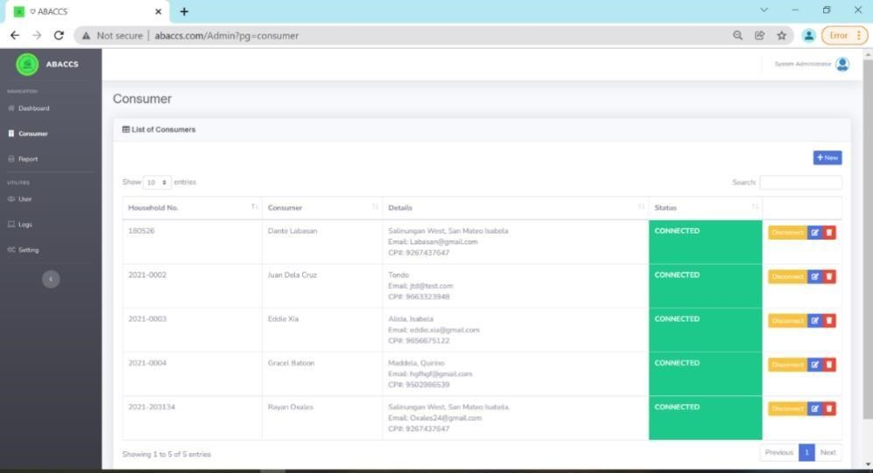

## Figure 18. ABACCS

Figure 18 shows the Arduino-Based Alternating Current (AC) Controller System

(ABACCS). The administrator in the Consumer module, where the admin can view the list of the consumers and control their status. Then, by clicking the ‘disconnect or reconnect’ button, the administrator can control the supply of electricity to a consumer and, at the same time, it automatically sends an SMS notice to the consumer's connectivity.

**4.2 Developed a prototype that controls the connectivity of the household’s electric current.**

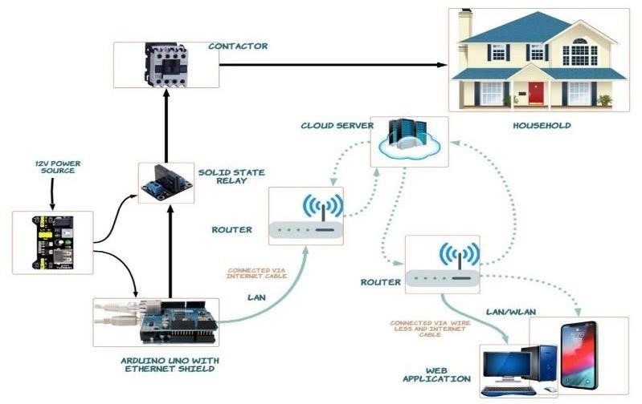

## Figure 19 (Hardware) Components of the Arduino-based Device Controller

To answer objective number two (2) the following components were used in this project; Arduino UNO R3, Ethernet Shield, Breadboard 200 points, jumper wires (malefemale, malemale), 5V 1 channel solid state relay, USB to Serial cable, 12 volts DC power adapter with a 3way splitter, 5 volts power supply module, Router, Contactor, and 5 volts mini fan. The purpose of the developed prototype was to control the electric line of the consumer and in order to test the functionality of the web-based system.

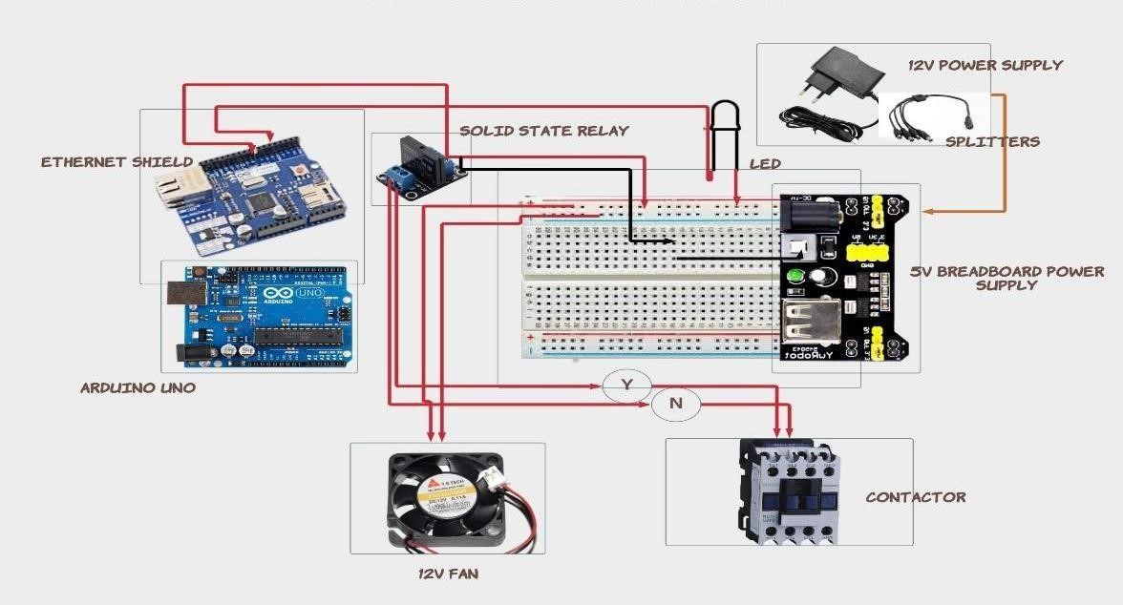

## Figure 20. Wiring Diagram of the Arduino-based Device Controller

Figure 20 shows the wiring diagram of the Arduino-based Device Controller. The main board of the operation is the Arduino Uno R3 in combination with an Ethernet Shield. The Ethernet Shield served as the connection between the web application and the Arduino device. The five (5) volt breadboard acts as the power supply for the relay. The twelve (12) DC power adapters with a 3-way splitter served as the power supply of each module. The

Solid-State Relay is used as a switch to turn on or off the contactor. The 5 volts’ Mini fan served as an exhaust fan to circulate the air temperature. The contactor serves as the main switch of the electric line that can hold 220 volts.



F



*igure 21 Developed Prototype of ABACCS*

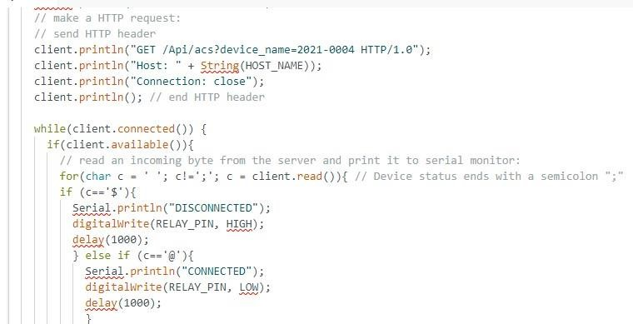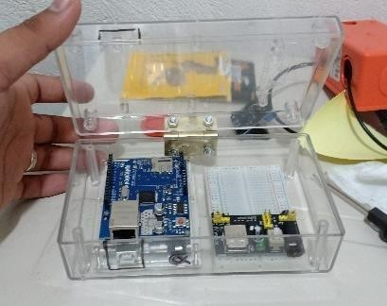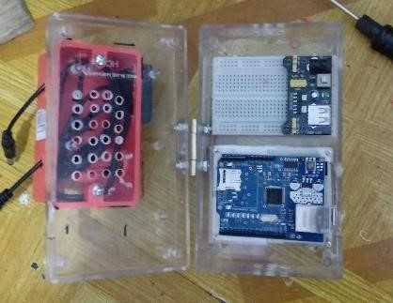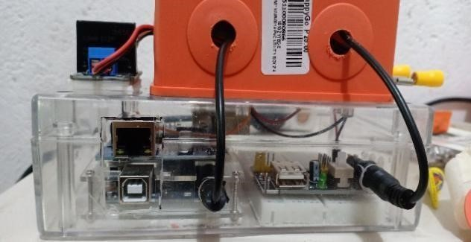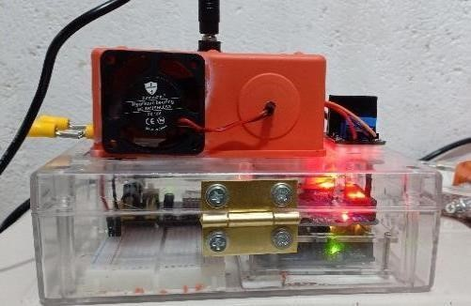

Figure 21 shows the developed prototype. The ABACCS device was built in a utility box with a 15.98 cm length x 9.15 cm width x 5.26 cm height. The Arduino Uno with Ethernet shield and the breadboard with a 5-volt power supply module were placed inside the utility box. The junction box at the top of the utility box is where the splitter and 5-volt mini fan were placed. The Solid-State Relay was fixed on the right side of the junction box. With the use of the Arduino IDE, the code for the program was uploaded to the Arduino Uno.

*Figure 22. Installation and Testing of the System*

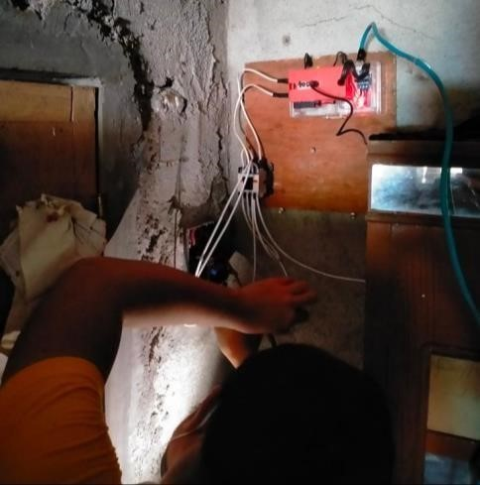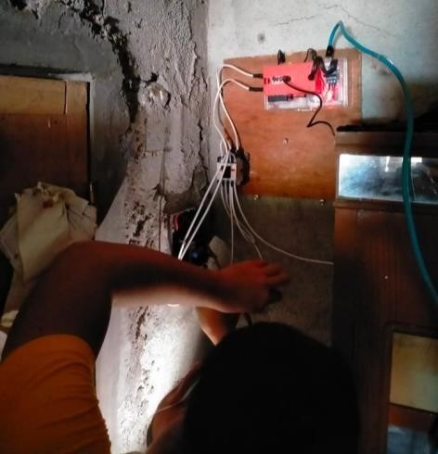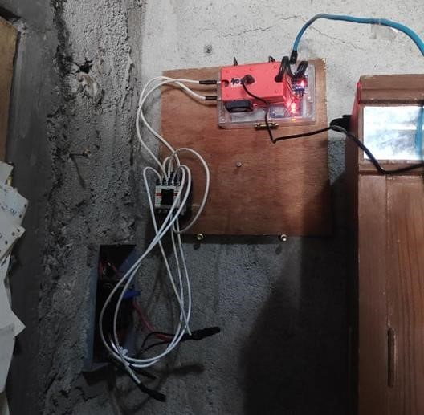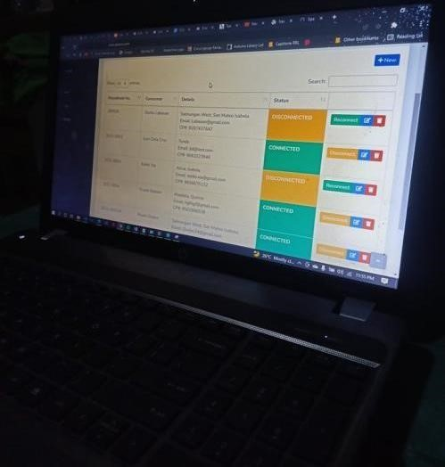

The device was installed on a house and tested on January 17, 2022 in San Mateo, Isabela, in collaboration with Engr. Aldwin Macatbag, an Electrical Engineer of ISELCO 1, Alicia, Isabela. The device was installed alongside the fuse to test the functionality of the device and to avoid a short circuit in case the device doesn’t work successfully. The testing and installation of the device were successful.

**4.3. Test the functionalities of the system for the:**

**4.3.1. Administrator to:**

● Login to the system

The Isabela I Electric Cooperative (ISELCO 1) served as the administrator and sub administrator of the system. The login page is for the administrator to enter two pieces of information, first a username and then a password, in order for the administrator to fully access the system, as shown in figure 23.

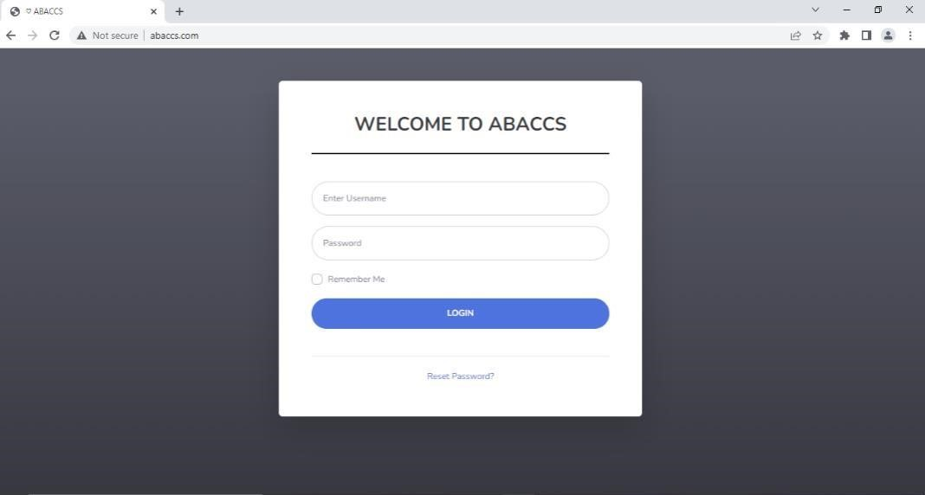

## Figure 23. Login Page

The page required the administrator to input two valid pieces of information, such as username and password. If the admin successfully logged in to the system by entering their username and password and clicking the button "Login". However, if the user forgets their password, they can reset it by clicking "Reset password." Then the page required the user to input their valid username and pin code into the system. After inputting the username and pin code, the system automatically generates a new password. The purpose of the login page is to provide security and to prevent unauthorized users from accessing the confidential data of the system.

* **View the total consumer and status of consumer statistics in graphical format**

The administrator has the privilege to view and monitor the total consumer and consumer status in graphical format. The administrator can visualize the data on disconnection and reconnection via a chart. This helps ISELCO 1 in decision making.



*Figure 24. Dashboard*

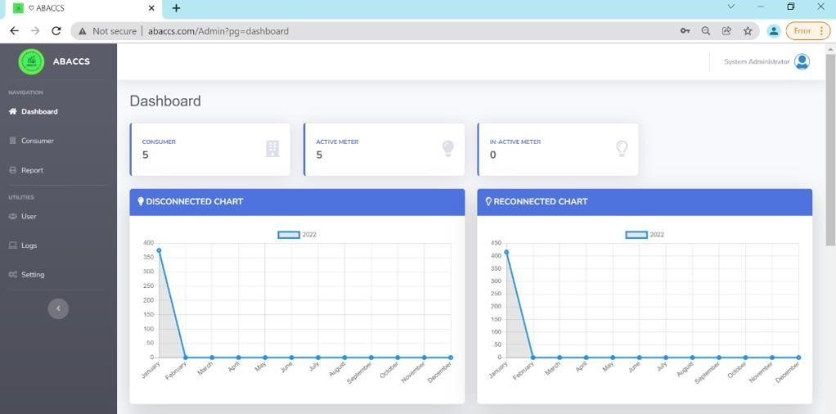

Figure 31 shows the dashboard page of the system where the administrator has the ability to monitor the total number of consumers, active and inactive meters. This page also shows the disconnection and reconnection charts. The researcher chose to display the result on a number for better and easier data analysis.

* Manage consumer’s information

On this page, the administrator can manage the consumer information and has three (3) options to take on this page, such as "Disconnect or Reconnect", "Edit", and "Delete" buttons, as shown in figure 25.



*Figure 25. Manage Consumer Page*

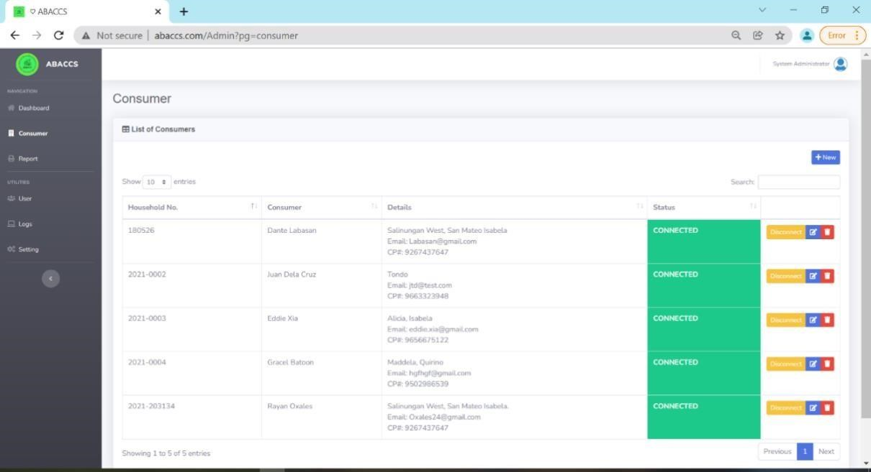

Figure 25 shows the ability of the administrator to manage the consumer information, which comprises the household number, consumer details, and status. This page also monitors the consumer status, whether it is connected or disconnected. The "Edit" button is for the admin to manage the details of the consumers, and the "Delete" button.

So that the administrator can add a new consumer by clicking the ‘+New’ button as shown in figure 26.

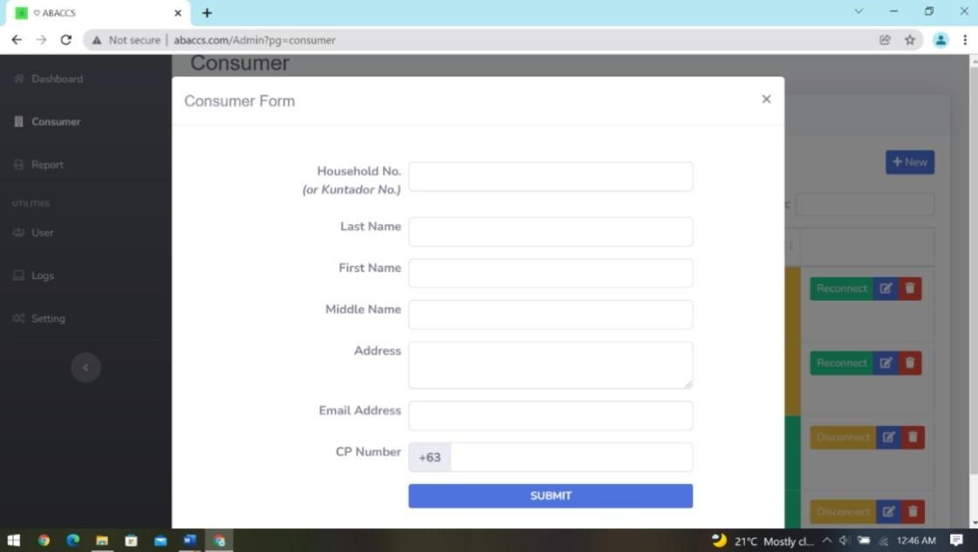

## Figure 26. Consumer form

Figure 26 shows the consumer form where the administrator can add a new consumer. The administrator can add through the ‘submit’ button which comprises household no, last name, first name, middle name, address, email address, and phone number for the SMS notification.

This feature of the system would be helpful to Iselco 1, since it replaces the manual method of profiling consumers, where the disconnection head of Iselco 1 can easily monitor all the consumers and improve the manual method of profiling consumers.

● Manage user accounts

The disconnection head of ISELCO 1 served as the administrator of the system. One of the privileges of the administrator is to manage the user accounts by entering their details into the system, including the username, password, and pin code, as shown in figures 27 and 28.



l

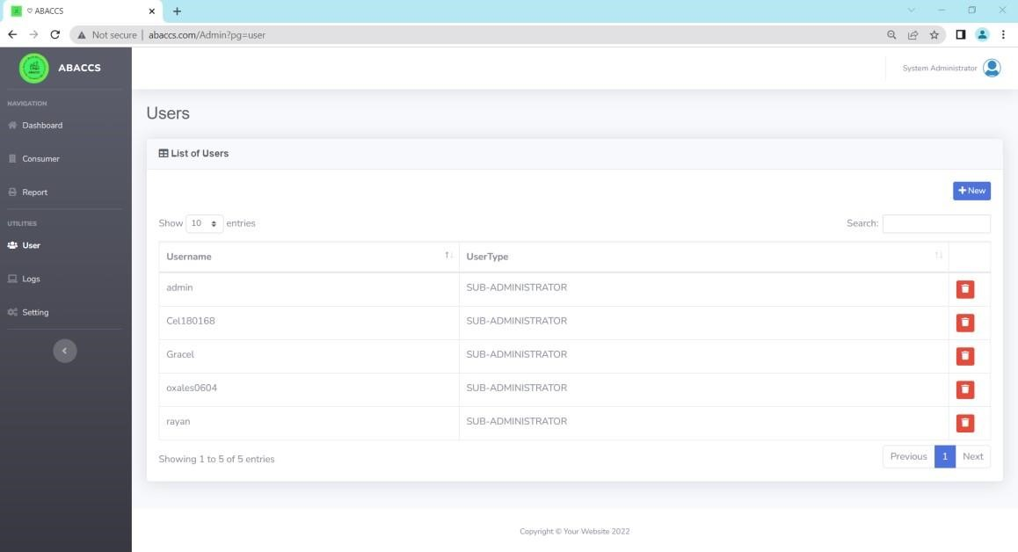

## Figure 27. Manage Users Account

Manage the user account by adding the information of the sub administrator who will manage the system when the administrator is not around. As shown in figure 27, the user page displayed the registered sub administrator. This page allows the administrator to add users and view and delete records. The ‘new’ button on this page allows the administrator to add a new user as a sub administrator of the system, as shown in Figure 28, the User Form.



*Figure 28. Users Form*

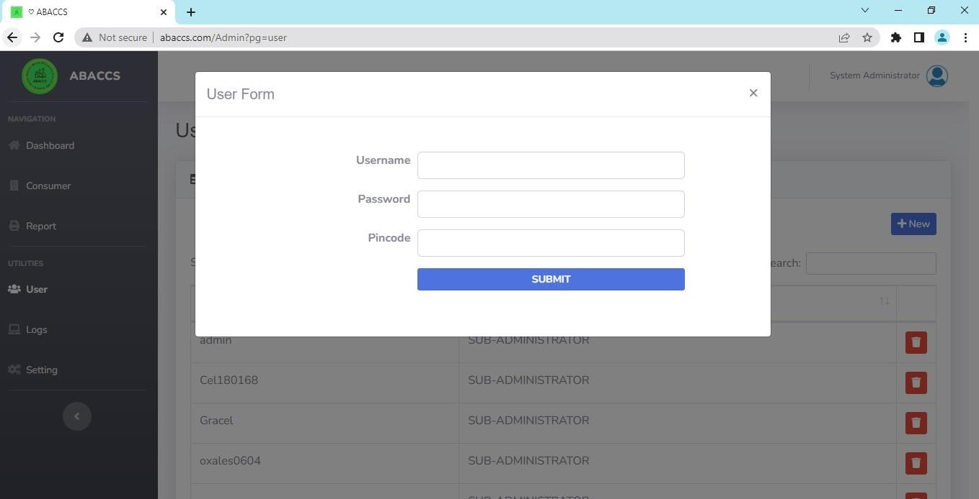

Figure 28 shows the user form where the administrator can add the details of the new sub administrator of the system. A username, password, and pin code have been entered by the administrator. Through this feature, the administrator can authorize users who can access the system for security purposes.

• Send connectivity notice to the consumer through SMS Notification

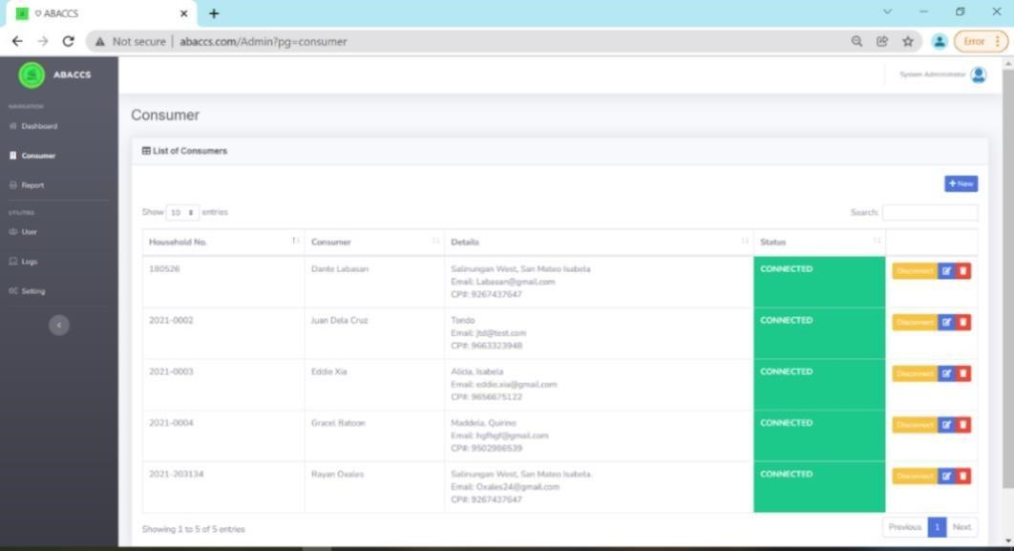

## Figure 29. Send Connectivity Notice

The administrator could control the electric line of a consumer by clicking the ‘Disconnect and Reconnect’. The web-based system will automatically send an SMS notification to the consumer with their connectivity status and to pay their unpaid bill for reconnection and remind the consumer to pay on time to prevent disconnection.

● Print list of connected and disconnected consumers reports

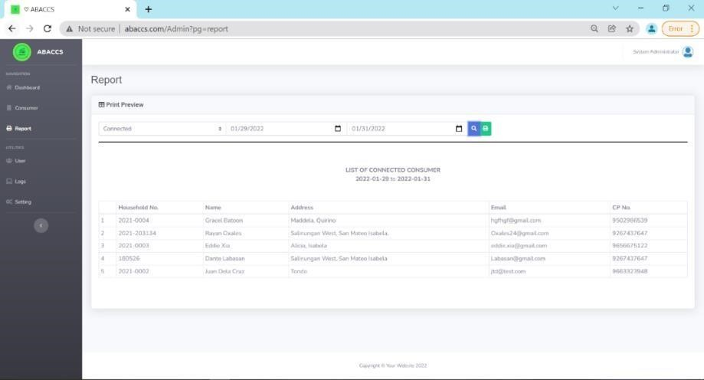

## Figure 30. list of Consumer Report

The administrator has access to the system and can monitor and print out the list of consumer status; take an action on this page through the ‘calendar’ button to select the dates when the consumer disconnects or reconnects, which can be monthly, annually, or quarterly; the

‘search’ button finds the list of consumer status; and the ‘print’ button to provide reports as shown in figure 30.

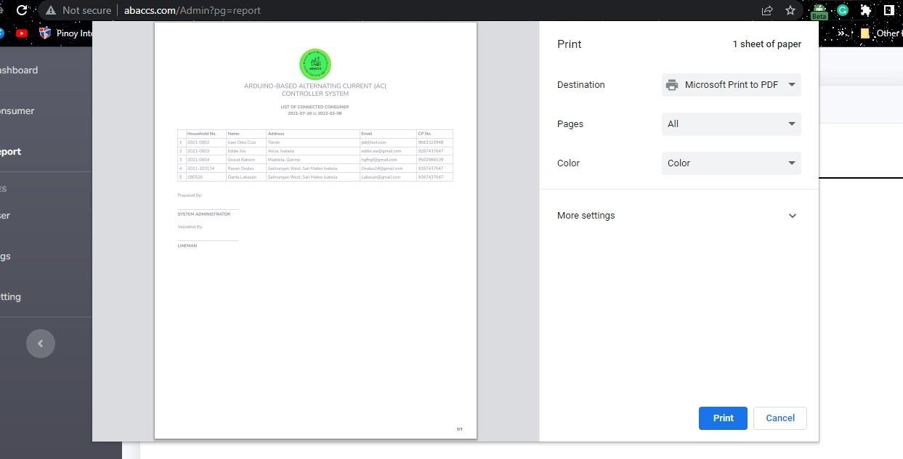

## Figure 31. Print Consumer Report

Figure 31 shows the printed report of all consumers with their status of connectivity. The administrator can easily print out the list of consumers, whether it is disconnected or reconnected, and can sort the status of the consumer. This feature provides a printable report of consumer status for ISELCO 1. This feature is monitored by the administrator.

**4.3.2. Consumer to:**

● Receive connectivity notice through SMS Notification

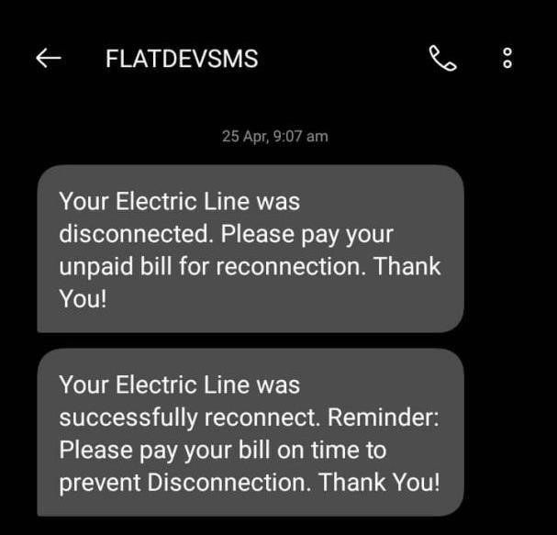

*Figure 32.* Receive Connectivity Notice

Figure 32 shows the Received Connectivity Notice of the consumer wherein the researcher used an SMS notification to notify the consumer of their connectivity status. This message states that the consumer pays their unpaid bills for reconnection and reminds the consumer to pay on time to prevent disconnection.

### 4.4 Evaluation Result (ISO 25010)

In order to achieve the fourth objective of this study and to determine the quality of the system, the researchers adopted the Product Quality Standard Questionnaire from the study ICtechMUPO: An Evaluation of Information E-Learning Module System for Faculty and Students by Flaviano L. Urera Jr. and Francis F. Balahadia. The respondents of the system evaluation in this study were electrical engineers, clients, and IT experts of ISELCO 1. The total number of respondents who participated in the evaluation of the system is twenty (20).

**Table 7.** Perception of the respondents in terms of Functional Suitability

|  |  |  |
| --- | --- | --- |
| **Questionnaires** | **Mean Value** | **Qualitative Rating** |
| **Functional Suitability** | |  |
| The set of functions covers all the specified tasks and user objectives. | 4.44 | Strongly Agree |
| The function provides the correct results with the needed degree of precision. | 4.39 | Strongly Agree |
| The function facilities the accomplishments of specified tasks and objectives. | 4.72 | Strongly Agree |
| **Grand Mean** | **4.52** | **Strongly Agree** |

Table 7 shows the Mean Evaluation of the Developed System’s Compliance to the ISO 25010 Quality Standard in terms of Functionality Suitability. Overall, the system obtained a grand mean of 4.52 from IT experts, clients, and electrical engineers, which is equivalent to "Very Great Extent". This statistically implies that the developed system is fully functional and meets the functionality requirements in that it provides functions that meet stated and implied needs when used under specified conditions by the IT Experts, Clients, and Electrical Engineers respondents.

**Table 8.** Perception of the respondents in terms Usability.

|  |  |  |
| --- | --- | --- |
| **Questionnaires** | **Mean Value** | **Qualitative Rating** |
| **Usability** | |  |
| Users can recognize whether system is approximate for their needs. | 4.53 | Strongly Agree |
| The system enables the user to learn how to use it with effectiveness, efficiency in emergency. | 4.53 | Strongly Agree |
| The system protects users against making errors | 4.44 | Strongly Agree |
| A user interface enables pleasing and satisfying interaction for user. | 4.44 | Strongly Agree |
| The system can be used by people with the widest range of characteristics and capabilities to achieve a specified goal in a special context of use. | 4.6 | Strongly Agree |
| **Grand Mean** | **4.51** | **Strongly Agree** |

Table 8 shows the Mean Evaluation of the Developed System’s Compliance to the ISO 25010 Quality Standard in Terms of Usability. Overall, the system obtained a grand mean of 4.51 from IT experts, clients, and electrical engineers, which is equivalent to "Very Great Extent." This statistically implies that the developed system is fully functional and meets the usability requirements such that it can be used by specified users to achieve specified goals with effectiveness, efficiency, and satisfaction in a specified context of use by the IT Experts, Clients, and Electrical Engineers respondents.

**Table 9.** Perception of the respondents in terms in Reliability.

|  |  |  |
| --- | --- | --- |
| **Questionnaires** | **Mean Value** | **Qualitative Rating** |
| **Reliability** | |  |
| The system meets for reliability under normal operation | 4.57 | Strongly Agree |
| The system is operational and accessible when required use. | 4.34 | Strongly Agree |
| The system operates as intended despite the presence of hardware or software results. | 4.28 | Strongly Agree |
| In the event of an interruption or a failure, a system can recover the data establish the desired state of the system. | 4.41 | Strongly Agree |
| **Grand Mean** | **4.40** | **Strongly Agree** |

Table 9 shows the Mean Evaluation of the Developed System’s Compliance to the ISO 25010 Quality Standard in terms of Reliability. Overall, the system obtained a grand mean of 4.40 from IT experts, clients, and electrical engineers, which is equivalent to "Very Great Extent." This statistically implies that the developed system is fully functional and meets the reliability requirements, meaning that it performs specified functions under specified conditions for a specified period of time as specified by the IT Experts, Clients, and Electrical Engineers respondents.

**Table 10.** Perception of the respondents in terms in Security

|  |  |  |
| --- | --- | --- |
| **Questionnaires** | **Mean Value** | **Qualitative Rating** |
|  | **Security** |  |
| This prototype ensures that data are accessible only to those authorized to have access. | 4.56 | Strongly Agree |
| A system, product or components prevents unauthorized access to, or modification of, computer programs or data. | 4.54 | Strongly Agree |
| Actions or events can prove to have taken place, so that the events or actions cannot be repudiated later. | 4.41 | Strongly Agree |
| **Grand Mean** | **4.50** | **Strongly Agree** |

Table 10 shows the Mean Evaluation of the Developed System’s Compliance to the ISO 25010 Quality Standard in terms of Security. Overall, the system obtained a grand mean of 4.50 from IT experts, clients, and electrical engineers, which is equivalent to "Very Great Extent". This statistically implies that the developed system is fully functional and meets the security requirements of which the system protects information and data so that people or other products or systems have the degree of data access appropriate to their types and levels of authorization. respondents included IT Experts, Clients, and Electrical Engineers

**Table 11.** Perception of the respondents in terms in Maintainability.

|  |  |  |  |
| --- | --- | --- | --- |
| **Questionnaires** | **Mean Value** | **Qualitative Rating** | |
| **Maintainability** | |  | |
| The system program is composed id discrete components such that a change has minimal impact on the other components. | 4.57 |  | Strongly Agree |
| An asset can be used in more than one system. | 4.42 |  | Strongly Agree |
| Possible of access the impact on the system of an intended change to one or more of its parts, or to diagnose a product for deficiencies or cause of failures, or to identify parts to be modified | 4.32 |  | Strongly Agree |
| The system can be efficiently modified without introducing defects or degrading existing product quality. | 4.44 |  | Strongly Agree |
| Test criteria can be established for a system and tests can be performed to determine whether those criteria have been met. | 4.44 |  | Strongly Agree |
| **Grand Mean** | 4.44 |  | Strongly Agree |

Table 11 shows the Mean Evaluation of the Developed System’s Compliance to the ISO 25010 Quality Standard in terms of Maintainability. Overall, the system obtained a grand mean of 4.44 from IT experts, clients, and electrical engineers, which is equivalent to "Very Great Extent." This statistically implies that the developed system is fully functional and meets the maintainability requirements of the degree of effectiveness and efficiency with which a product or system can be modified to improve it, correct it, or adapt it to changes in the environment and requirements by the IT Experts, Clients, and Electrical Engineers respondents. Table 12. Summary

|  |  |  |
| --- | --- | --- |
| **Questionnaires** | **Mean Value** | **Qualitative Rating** |
| Functional Suitability | 4.52 | Strongly Agree |
| Usability | 4.51 | Strongly Agree |
| Reliability | 4.37 | Strongly Agree |
| Security | 4.50 | Strongly Agree |
| Maintainability | 4.44 | Strongly Agree |
| **Grand Mean** | **4.47** | **Strongly Agree** |

Table 12 shows the overall mean on the evaluation of the developed system’s compliance with the ISO 25010 Quality Standard. The grand mean of 4.47 with a qualitative rating interpretation of "Strongly Agree" statistically implies that in terms of functional suitability, usability, reliability, security, and maintainability, the developed system application met the needs and requirements of the IT experts and client and electrical engineer. This only means that respondents believe that the system was capable of disrupting the supply of electricity to a household.

## CHAPTER V

SUMMARY, CONCLUSIONS AND RECOMMENDATIONS

This chapter presents the summary, which describes all the actions involved in the project’s development as well as the many tools used. It also includes the conclusion in which all of the system's primary functionalities provide the proper solution to the difficulties encountered by the company.

### 5.1. Summary

The Arduino-based Alternating Current System is an effective and efficient tool in managing in terms of disrupting the supply of electricity lines for each client of ISELCO 1. The researchers conducted a study at Isabela Electric Cooperative (ISELCO I), Alicia, Isabela. During the conduct of the feasibility study, it was discussed that though ISELCO 1 had already modernized their billing and collection system, the disconnection and reconnection process remained the same. When a particular household is due for disconnection, a line worker will manually cut the electrical flow from the meter reader, terminating the electricity from the distribution line or the transformer. The researchers aim to improve the traditional way of disrupting electricity lines by using ISELCO1. The researchers came up with the solution entitled "ARDUINO-BASED ALTERNATING CURRENT (AC) CONTROLLER SYSTEM", to eliminate the manual tasks in disrupting the supply of electricity to a household, which has the following features: remotely controlling the electricity line of a particular house hold with different components such as: Arduino Uno, Solid-state Relay, Ethernet Shield, and Contactor; creating a web-based application (ABACCS) that contains a dashboard for easily monitoring the active meter, inactive meter, and total consumer; disconnection and reconnection chart for data reasoning; controlling the electric line of a household; SMS notification for disconnection and reconnection; and with a middle script security.

In developing the project, the researchers used the Rapid Application Diagram (RAD) Methodology shown in chapter 3.8 of the system design, which uses minimal planning in favor of rapid prototyping.

The web-based application was designed and developed using bootstrap and a combination of PHP and MYSQL server to manage data inputs to the system. The ABACCS device was built using the Arduino Uno, Solid-Sate Relay, Ethernet Shield, and Contactor. After the completion of the system and device functionalities, they were evaluated using questionnaires in terms of ISO 25010 with the following criteria: Functional Suitability, Usability, Reliability, Security, Maintainability, Freedom from Risk. Evaluation result was then gathered and analyzed using Likert Scale and descriptive analysis.

### 5.2. Conclusions

After the successful development of the Arduino-Based Alternating Current Controller System, the researchers concluded that the Arduino-based alternating current control system was developed to help ISELCO disrupt the supply of electricity through various strategic objectives.

The developed system can effectively and efficiently manage consumers by controlling the supply of electricity and providing a safe process of disruption of electricity. After the development of the system, the researchers conducted security tests to make sure the user is safe while using our system. The researchers checked for URL manipulation using HTTP methods. Lastly, the researchers also checked the hardware to ensure each consumer is safe when the device is installed in their household. The researcher consults an electrical engineer for verification and also tests the device. The result of the system’s evaluation has an overall mean of 4.51 from an IT expert, client, and electrical engineer with a qualitative rating interpretation of "Strongly Agree." Hence, users' comfort and confidence in using the application demonstrated that they are satisfied with the features and information generated, indicating that the system is highly accepted. After testing the developed system, the researchers immediately implemented it by making a video guide on how to use the system, both in sub-admin and admin roles, and it was tested and used by several users while gathering feedback and giving them the chance to evaluate the system.

### 5.3. Recommendation

Based on the result of the study, the following are recommended additional system features that the for future researchers may undertake:

1. A monitoring module in the system may be included.
2. A module for tracking daily consumption in the device may be included.
3. An alternative way to access the device, such as SMS and internet Powerline may be included.
4. An emergency battery may be included.

BIBLIOGRAPHY

## BIBLIOGRAPHY

Al-Abri, Dawood & Malik, Arif & Albadi, Mohammed & Charabi, Yassine & Hosseinzadeh, Nasser. (2015).

Smart Grid. 10.1007/978-1-4614-6431-0-78-1.

Al-Mayouf Y.R. Accident Management System Based on Vehicular Network for an

Intelligent Transportation System in Urban Environments <https://trid.trb.org/view/1514063>

Alotaibi, Ibrahim & Abido, Mohammed & Savkin, Andrey. (2020).

A Comprehensive Review of Recent Advances in Smart Grids: A Sustainable Future with Renewable Energy Resources. Energies. 13. 6269.

10.3390/en13236269.

Arduino IDE and Software Development <http://www.arduino.cc/>

Cecati, C. Citro, A. Piccolo and P. Siano,

"Smart Operation of Wind Turbines and Diesel Generators According to Economic Criteria,” in IEEE Transactions on Industrial Electronics, vol. 58, no. 10, pp. 4514-4525, Oct. 2011, doi: 10.1109/TIE.2011.2106100.

Cecati, Carlo & Mokryani, Geev & Piccolo, Antonio & Siano, Pierluigi. (2010). An overview on the Smart Grid concept. IECON Proceedings (Industrial Electronics Conference). 3322 - 3327. 10.1109/IECON.2010.5675310.

Existing Systems <http://www.electricity-biling-meter.com/>

Floyd (1984), Prototyp` ing and Software Development Approaches [https://www.academia.edu/2563255/Prototyping_and_Software_Development_A pproaches.](https://www.academia.edu/2563255/Prototyping_and_Software_Development_Approaches)

Gubbi, J., Buyya, R., Marusic, S. and Palaniswami, M. (2013) Internet of Things (IoT):

A Vision, Architectural Elements, and Future Directions. Future Generation Computer Systems, 29, 1645-1660.

<http://dx.doi.org/10.1016/j.future.2013.01.010>

Internet of Things <https://link.springer.com/book/10.1007/978-3-642-11710->

7?noAccess=true&error=cookies_not_supported&code=27a350f9-cae6-43a1b7338c64743183ea

J. Cynthia, C. Bharathi Priya, P. A. Gopinath, “IOT based Smart Parking Management

System”

International Journal of Recent Technology and Engineering (IJRTE) (ISSN:

2277-3878, Volume-7 Issue-4S, November2018).

Lestari, Uning et al.

“APPLICATION OF HOME LIGHT CONTROL SYSTEM USING ARDUINO

WITH MOBILE BASED WIFI MEDIA.” (2019).

Maher Hassan Kadhim,

“Arduino Smart Parking Manage System based on Ultrasonic Internet of Things

(IoT) Technologies”, International

Journal of Engineering & Technology, 7 (3.20) (2018).

Miguel, Mauricio, & Rodríguez, 2014,

CaixaBank obtains the ISO/IEC 25000 Functional Suitability certificate for their app

CaixaBankNow https://iso25000.com/index.php/en/iso-25000-standards/iso-25010

Mosa, Msbah & Albatish, Islam & Abu-Naser, Samy. (2018).

`ASP.NET-Tutor: Intelligent Tutoring System for leaning ASP.NET.

Nasution, Tigor & Muchtar, Muhammad & Siregar, Ikhsan & Andayani, Ulfi & Christian, Esra & Sinulingga, Emerson. (2017).

Electrical appliances control prototype by using GSM module and Arduino. 355358.

10.1109/IEA.2017.7939237.

Prepaid Electricity | Meralco [https://www.meralco.com.ph/residential/electricservice/prepaid-electricity](https://www.meralco.com.ph/residential/electric-service/prepaid-electricity)

Providing Fault Tolerance via Complex Event Processing and Machine Learning for IoT Systems.

<https://dblp.org/db/conf/iot/iot2019.html>

Prototype (video game) https://en.wikipedia.org/wiki/Prototype_(video_game)

Rapid Application Development (RAD) | Definition, Steps & Full Guide

https://kissflow.com/low-code/rad/rapid-application-development/

Smart grids and meters https://energy.ec.europa.eu/topics/markets-and-consumers/smart-gridsand-

meters_en

Software Development Life Cycle [https://www.tutorialspoint.com/software_engineering/software_development_life cycle.htm](https://www.tutorialspoint.com/software_engineering/software_development_lifecycle.htm)

T. Narmada, Dr. M.V. Lakshmaiah and N.N. Nagamma,

“Design and Development of Pre-paid electricity billing using Raspberry Pi2”,

International Journal of Electronics Engineering Research. vol. 9, no. 7, pp. 995- 1005, 2017

The spatio-temporal variability of droughts using the standardized precipitation index in Yunnan, China - Scientific Figure on ResearchGate.

Available from:

[https://www.researchgate.net/figure/Relationship-between-drought-affected-areaa](https://www.researchgate.net/figure/Relationship-between-drought-affected-area-)nd-

drought-intensity_fig4_316746875 [accessed 20 Jun 2022]

United Nations Sustainable Development <https://www.un.org/sustainabledevelopment/energy/>

What Is Rapid Application Development (RAD)?

<https://blog.capterra.com/what-is-rapid-application-development/>

BIBLIOGRAPHY

## BIBLIOGRAPHY

Al-Abri, Dawood & Malik, Arif & Albadi, Mohammed & Charabi, Yassine & Hosseinzadeh, Nasser. (2015).

Smart Grid. 10.1007/978-1-4614-6431-0-78-1.

Al-Mayouf Y.R. Accident Management System Based on Vehicular Network for an

Intelligent Transportation System in Urban Environments <https://trid.trb.org/view/1514063>

Alotaibi, Ibrahim & Abido, Mohammed & Savkin, Andrey. (2020).

A Comprehensive Review of Recent Advances in Smart Grids: A Sustainable Future with Renewable Energy Resources. Energies. 13. 6269.

10.3390/en13236269.

Arduino IDE and Software Development <http://www.arduino.cc/>

Cecati, C. Citro, A. Piccolo and P. Siano,

"Smart Operation of Wind Turbines and Diesel Generators According to

Economic Criteria,” in IEEE Transactions on Industrial Electronics, vol. 58, no. 10, pp. 4514-4525, Oct. 2011, doi: 10.1109/TIE.2011.2106100.

Cecati, Carlo & Mokryani, Geev & Piccolo, Antonio & Siano, Pierluigi. (2010). An overview on the Smart Grid concept. IECON Proceedings (Industrial Electronics Conference). 3322 - 3327. 10.1109/IECON.2010.5675310.

Existing Systems <http://www.electricity-biling-meter.com/>

Floyd (1984), Prototyp` ing and Software Development Approaches

[https://www.academia.edu/2563255/Prototyping_and_Software_Development_A pproaches.](https://www.academia.edu/2563255/Prototyping_and_Software_Development_Approaches)

Gubbi, J., Buyya, R., Marusic, S. and Palaniswami, M. (2013) Internet of Things (IoT): A Vision, Architectural Elements, and Future Directions. Future Generation Computer Systems, 29, 1645-1660.

<http://dx.doi.org/10.1016/j.future.2013.01.010>

Internet of Things <https://link.springer.com/book/10.1007/978-3-642-11710->

7?noAccess=true&error=cookies_not_supported&code=27a350f9-cae6-43a1b7338c64743183ea

J. Cynthia, C. Bharathi Priya, P. A. Gopinath, “IOT based Smart Parking Management

System”

International Journal of Recent Technology and Engineering (IJRTE) (ISSN:

2277-3878, Volume-7 Issue-4S, November2018).

Lestari, Uning et al.

“APPLICATION OF HOME LIGHT CONTROL SYSTEM USING ARDUINO

WITH MOBILE BASED WIFI MEDIA.” (2019).

Maher Hassan Kadhim,

“Arduino Smart Parking Manage System based on Ultrasonic Internet of Things

(IoT) Technologies”, International

Journal of Engineering & Technology, 7 (3.20) (2018).

Miguel, Mauricio, & Rodríguez, 2014,

CaixaBank obtains the ISO/IEC 25000 Functional Suitability certificate for their app

CaixaBankNow https://iso25000.com/index.php/en/iso-25000-standards/iso-25010

Mosa, Msbah & Albatish, Islam & Abu-Naser, Samy. (2018).

`ASP.NET-Tutor: Intelligent Tutoring System for leaning ASP.NET.

Nasution, Tigor & Muchtar, Muhammad & Siregar, Ikhsan & Andayani, Ulfi & Christian, Esra & Sinulingga, Emerson. (2017).

Electrical appliances control prototype by using GSM module and Arduino. 355358.

10.1109/IEA.2017.7939237.

Prepaid Electricity | Meralco [https://www.meralco.com.ph/residential/electricservice/prepaid-electricity](https://www.meralco.com.ph/residential/electric-service/prepaid-electricity)

Providing Fault Tolerance via Complex Event Processing and Machine Learning for IoT Systems.

<https://dblp.org/db/conf/iot/iot2019.html>

Prototype (video game) https://en.wikipedia.org/wiki/Prototype_(video_game)

Rapid Application Development (RAD) | Definition, Steps & Full Guide

https://kissflow.com/low-code/rad/rapid-application-development/

Smart grids and meters https://energy.ec.europa.eu/topics/markets-and-consumers/smart-gridsand- meters_en

Software Development Life Cycle

[https://www.tutorialspoint.com/software_engineering/software_development_life cycle.htm](https://www.tutorialspoint.com/software_engineering/software_development_lifecycle.htm)

T. Narmada, Dr. M.V. Lakshmaiah and N.N. Nagamma,

“Design and Development of Pre-paid electricity billing using Raspberry Pi2”,

International Journal of Electronics Engineering Research. vol. 9, no. 7, pp. 995- 1005, 2017

The spatio-temporal variability of droughts using the standardized precipitation index in Yunnan, China - Scientific Figure on ResearchGate.

Available from:

[https://www.researchgate.net/figure/Relationship-between-drought-affected-areaa](https://www.researchgate.net/figure/Relationship-between-drought-affected-area-)nd-

drought-intensity_fig4_316746875 [accessed 20 Jun 2022]

United Nations Sustainable Development <https://www.un.org/sustainabledevelopment/energy/>

What Is Rapid Application Development (RAD)?

<https://blog.capterra.com/what-is-rapid-application-development/>

APPENDICES

## Appendix A Relevant Source Code

**Relevant Source Code**

### Disconnection and reconnection

<?php

defined('BASEPATH') OR exit('No direct script access allowed'); date_default_timezone_set('Asia/Manila');

/**

* */

class Api extends CI_Controller

{

public function __construct()

{

parent::__construct(); $this->load-

>model('Crudx');

}

// http://abaccs.com/Api/acs?device_name=[value] public function acs(){

$device_name = $_GET['device_name'];

$sql = "SELECT device_status FROM devices_status

WHERE device_name='$device_name' LIMIT 1";

$result = $this->Crudx->retrieve($sql); if

($result->num_rows > 0) {

while ($row = $result->result())

{

echo $row->device_status;

}

} else { echo "Error:" . $sql; }

}

}

?>

### LOGIN

public function login()

{

$username = $this->input->post('username');

$password = $this->input->post('password');

#--

$get = $this->Crudx->retrieve(" SELECT * FROM abaccs_user

WHERE username = '".$username."' LIMIT 1 ");

if($get->num_rows() > 0)

{

$res = $get->row();

$data = array(

|  |  |  |
| --- | --- | --- |
| 'id' |  | => $res->userid, |
| 'usertype' |  | => $res->usertype, |
| 'logged_in' | => | TRUE |

);

if(password_verify($password, $res->password) && $res-

>usertype == 'administrator')

{

$this->session->set_userdata($data);

$this->Crudx->create('abaccs_userlog',

array('userid'=>$this->session->userdata('id'), 'log' => date('Y-m-d H:i:s'),

'activity'=>'User In-Session'));

redirect('Admin?pg=dashboard');

}

else if(password_verify($password, $res->password) && $res->usertype == 'other')

{

$this->session->set_userdata($data);

$this->Crudx->create('abaccs_userlog',

array('userid'=>$this->session->userdata('id'), 'log' => date('Y-m-d H:i:s'),

'activity'=>'User In-Session'));

redirect('Other?pg=dashboard');

} else

{

redirect('Authenticate?cb=false2');

}

} else

{

redirect('Authenticate?cb=false4');

}

}

### LOGOUT

public function logout()

{

$this->Crudx->create('abaccs_userlog', array('userid'=>$this-

>session->userdata('id'), 'log' => date('Y-m-d H:i:s'), 'activity'=>'User EndSession'));

$array_items = array('id', 'usertype', 'logged_in'); $this-

>session->unset_userdata($array_items); redirect('Authenticate?cb=login');

}

### RESET

public function resetForm(){

$username = $this->input->post('username');

$pincode = $this->input->post('pincode');

$get = $this->Crudx->retrieve(" SELECT * FROM abaccs_user

WHERE username = '".$username."' LIMIT 1 ");

if($get->num_rows() > 0){ $row = $get->row(); if($row->pincode ==

$pincode){

$rand = rand(0,9999);

$this->Crudx->update('abaccs_user', 'userid', $row-

>userid, array('password' => password_hash($username.$rand,

PASSWORD_DEFAULT)));

$this->Crudx->create('abaccs_sms', array('msg' =>

'Reset Password Successfully! Your new password is '.$username.$rand, 'to' =>

'0'.$row->cpno));

echo json_encode(array('cb' => 0, 'data' =>

array('username' => $username, 'pincode' => $rand)));

} else { echo

json_encode(array('cb' => 1));

}

} else {

echo json_encode(array('cb' => 2));

}

}

### ADMIN ACCESS

public function index()

{

if($this->session->userdata('logged_in') == TRUE)

{

$this->load->view('include/header'); $this-

>load->view('include/nav_admin');

switch ($this->session->userdata('usertype')) { case 'administrator':

switch (@ $_GET['pg']) { case 'dashboard':

$this->load-

>view('page/admin/dashboard');

$this->Crudx-

>create('abaccs_userlog', array('userid'=>$this->session->userdata('id'), 'log' => date('Ym-d H:i:s'), 'activity'=>'Redirect to Dashboard Page'));

break;

case 'consumer':

$this->load-

>view('page/admin/consumer');

$this->Crudx-

>create('abaccs_userlog', array('userid'=>$this->session->userdata('id'), 'log' => date('Ym-d H:i:s'), 'activity'=>'Redirect to Consumer Page'));

break;ate('abaccs_userlog',

array('userid'=>$this->session->userdata('id'), 'log' => date('Y-m-d H:i:s'),

'activity'=>'Redirect to Issuance Page'));

break;

case 'report':

$this->load-

>view('page/admin/report');

$this->Crudx-

>create('abaccs_userlog', array('userid'=>$this->session->userdata('id'), 'log' => date('Y-m-d H:i:s'), 'activity'=>'Redirect to Report Page'));

break;

case 'user': $this->load-

>view('page/admin/user');

$this->Crudx- >create('abaccs_userlog', array('userid'=>$this->session->userdata('id'), 'log' => date('Ym-d H:i:s'), 'activity'=>'Redirect to User Page'));

break;

case 'logs': $this->load-

>view('page/admin/logs');

$this->Crudx-

>create('abaccs_userlog', array('userid'=>$this->session->userdata('id'), 'log' => date('Ym-d H:i:s'), 'activity'=>'Redirect to Logs Page'));

break;

case 'setting':

$this->load-

>view('page/admin/setting');

$this->Crudx-

>create('abaccs_userlog', array('userid'=>$this->session->userdata('id'), 'log' => date('Y-m-d H:i:s'), 'activity'=>'Redirect to Setting Page'));

break;

default: $this->load-

>view('page/admin/dashboard');

$this->Crudx-

>create('abaccs_userlog', array('userid'=>$this->session->userdata('id'), 'log' => date('Ym-d H:i:s'), 'activity'=>'Redirect to Dashboard Page'));

break; }

break; case 'other':

redirect('Other?pg=dashboard'); break;

default: # code... break;

}

$this->load->view('include/footer');

} else

{

redirect('Authenticate');

}

}

### DASHBOARD

public function dashboard(){

echo json_encode(array(

'nums' => array(

|  |  |
| --- | --- |
| 'consumer' => $this->Crudx->retrieve(" SELECT * abaccs_consumer WHERE is_disable = 0 ")->num_rows(),    'active' => $this->Crudx->retrieve(" SELECT * FROM  abaccs_consumer WHERE status = 1 AND is_disable = 0 ")->num_rows(), | FROM |
| 'inactive' => $this->Crudx->retrieve(" SELECT * abaccs_consumer WHERE status = 0 AND is_disable = 0 ")->num_rows() | FROM |

),

'chart' => $this->Crudx->retrieve(" SELECT

abaccs_statuslog.* FROM abaccs_statuslog INNER JOIN abaccs_consumer ON abaccs_consumer.householdno = abaccs_consumer.householdno WHERE

DATE_FORMAT(abaccs_statuslog.dt, '%Y') = '".date('Y')."' AND abaccs_consumer.is_disable = 0 ")->result(),

'logs' => $this->Crudx->retrieve(" SELECT * FROM

abaccs_userlog ORDER BY log DESC LIMIT 100 ")->result()

));

### CONSUMER TABLE

public function consumerTable(){

echo json_encode($this->Crudx->retrieve(" SELECT * FROM

abaccs_consumer WHERE is_disable = 0 ")->result());

}

public function consumerFetch(){ echo json_encode($this-

>Crudx->retrieve(" SELECT * FROM abaccs_consumer WHERE householdno = '".$this->input->post('data[0]')."' LIMIT 1 ")->row());

}

public function consumerForm(){

$consumer = array(

|  |  |  |  |  |  |
| --- | --- | --- | --- | --- | --- |
|  | 'householdno' => | | $this->input->post('householdno'), | | |
| >post('lname'), | 'lname' |  |  | => | $this->input- |
| >post('fname'), | 'fname' |  |  | => | $this->input- |
| >post('mname'), | 'mname' |  |  |  | => $this->input- |
| >post('address'), | 'address' |  |  | => | $this->input- |
| >post('email'), | 'email' |  |  | => | $this->input- |
| >post('cpno') | 'cpno' |  |  | => | $this->input- |

);

if($this->input->post('householdno1') == ''){ $consumer['dtcreated'] = date('Y-m-d');

$this->Crudx->create('abaccs_consumer', $consumer);

$this->Crudx->create('abaccs_userlog',

array('userid'=>$this->session->userdata('id'), 'log' => date('Y-m-d H:i:s'),

'activity'=>'Added new consumer'));

} else {

$this->Crudx->update('abaccs_consumer', 'householdno',

$this->input->post('householdno1'), $consumer); $this->Crudx-

>create('abaccs_userlog', array('userid'=>$this->session->userdata('id'), 'log' => date('Y-m-d H:i:s'),

'activity'=>'Update consumer profile'));

}

}

### STATUS OF CONSUMER

public function status(){

$consumer = $this->Crudx->retrieve(" SELECT * FROM

abaccs_consumer WHERE householdno = '".$this->input->post('householdno')."' LIMIT

1 ")->row(); if($this->input->post('status') == 1){

$msg = 'Your Electric Line was successfully reconnect.

Reminder: Please pay your bill on time to prevent Disconnection. Thank You!';

} else {

$msg = 'Your Electric Line was disconnected. Please pay

your unpaid bill for reconnection. Thank You!';

}

//$sms = $this->Crudx->itexmo('0'.$consumer->cpno, $msg, 'TR- ÆNGO674058_8AWW8', '@t!)!b3c7a');

$this->Crudx->create('abaccs_statuslog', array('householdno' =>

$this->input->post('householdno'), 'status' => $this->input->post('status'), 'dt' => date('Ym-d H:i:s')));

$this->Crudx->update('abaccs_consumer', 'householdno', $this-

>input->post('householdno'), array('status' => $this->input->post('status')));

$this->Crudx->create('abaccs_sms', array('msg' => $msg, 'to' => '0'.$consumer->cpno));

$this->Crudx->create('abaccs_userlog', array('userid'=>$this-

>session->userdata('id'), 'log' => date('Y-m-d H:i:s'), 'activity'=>'Update consumer connection status'));

echo json_encode(array());

}

public function disable(){

$this->Crudx->update('abaccs_consumer', 'householdno', $this-

>input->post('data'), array('is_disable' => 1));

$this->Crudx->create('abaccs_userlog', array('userid'=>$this>session>userdata('id'), 'log' => date('Y-m-d H:i:s'), 'activity'=>'Disable consumer in the database'));

}

### REPORT

public function reportFetch(){

$this->Crudx->create('abaccs_userlog', array('userid'=>$this-

>session->userdata('id'), 'log' => date('Y-m-d H:i:s'), 'activity'=>'Fetch Report'));

echo json_encode($this->Crudx->retrieve(" SELECT DISTINCT abaccs_consumer.* FROM abaccs_consumer INNER JOIN abaccs_statuslog ON abaccs_consumer.householdno = abaccs_statuslog.householdno WHERE

abaccs_consumer.status = '".$this->input->post('data[0]')."' AND

(DATE_FORMAT(abaccs_statuslog.dt, '%Y-%m-%d') BETWEEN '".$this-

>input->post('data[1]')."' AND '".$this->input->post('data[2]')."') AND abaccs_consumer.is_disable = 0 ")->result());

}

### USER FORM

public function usersTable(){

echo json_encode($this->Crudx->retrieve(" SELECT * FROM

abaccs_user WHERE usertype != 'administrator' ")->result());

}

public function usersForm(){ if($this->input->post('userid') == ''){

$this->Crudx->create('abaccs_user', array(

|  |  |
| --- | --- |
| 'username' =>  >post('username'), | $this->input- |
| 'password' =>  >post('password'), PASSWORD_DEFAULT), | password_hash($this>input- |
| 'usertype' => | 'other', |
| 'pincode' | => $this->input- |

>post('pincode')

));

$this->Crudx->create('abaccs_userlog',

array('userid'=>$this->session->userdata('id'), 'log' => date('Y-m-d H:i:s'), 'activity'=>'Created new User'));

} else {

$this->Crudx->update('abaccs_user', 'userid', $this->input-

>post('userid'), array(

|  |  |
| --- | --- |
| 'username' =>  >post('username'), | $this->input- |
| 'password' =>  >post('password'), PASSWORD_DEFAULT), | password_hash($this>input- |
| 'pincode'  >post('pincode') | => $this->input- |

));

$this->Crudx->create('abaccs_userlog',

array('userid'=>$this->session->userdata('id'), 'log' => date('Y-m-d H:i:s'),

'activity'=>'Update User Account Credentials'));

}

}

public function changepasswordForm(){

$userid = $this->input->post('userid');

$password = $this->input->post('password');

$newpassword = $this->input->post('new_password');

$get = $this->Crudx->retrieve(" SELECT * FROM abaccs_user

WHERE userid = '".$userid."' LIMIT 1 ");

if($get->num_rows() > 0){ $row = $get->row();

if(password_verify($password, $row->password)){ $this->Crudx->update('abaccs_user', 'userid',

$userid, array('password' => password_hash($newpassword,

PASSWORD_DEFAULT))); echo json_encode(array('cb'=>0));

} else {

echo json_encode(array('cb'=>1));

}

} else {

echo json_encode(array('cb'=>2));

}

}

public function changeusernameForm(){

$userid = $this->input->post('userid');

$pincode = $this->input->post('pincode');

$newusername = $this->input->post('new_username');

$get = $this->Crudx->retrieve(" SELECT * FROM abaccs_user

WHERE userid = '".$userid."' LIMIT 1 ");

if($get->num_rows() > 0){ $row = $get->row(); if($pincode ==

$row->pincode){

$this->Crudx->update('abaccs_user', 'userid',

$userid, array('username' => $newusername));

echo json_encode(array('bc'=>0));

} else {

echo json_encode(array('bc'=>1));

}

} else {

echo json_encode(array('bc'=>2));

}

}

public function urcpnoForm(){

$this->Crudx->update('abaccs_user', 'userid', $this->input-

>post('userid'), array('cpno' => $this->input->post('cpno')));

}

public function userDelete(){

$this->Crudx->delete('abaccs_user', 'userid', $this->input-

>post('data'));

$this->Crudx->create('abaccs_userlog', array('userid'=>$this-

>session->userdata('id'), 'log' => date('Y-m-d H:i:s'), 'activity'=>'Delete User'));

}

### LOGS AND SETTINGS

public function userlogsTable(){ echo json_encode($this>Crudx->retrieve(" SELECT * FROM abaccs_userlog INNER JOIN abaccs_user ON abaccs_user.userid =

abaccs_userlog.userid LIMIT 10000 ")->result()); }

public function setting(){ echo json_encode(array(

'account' => $this->Crudx->retrieve(" SELECT *

FROM abaccs_user WHERE userid = '".$this->session->userdata('id')."' LIMIT 1 ")>row()

));

}

}

Appendix B

## Sample Input/Output/Report

### Sample Input/Output/Report

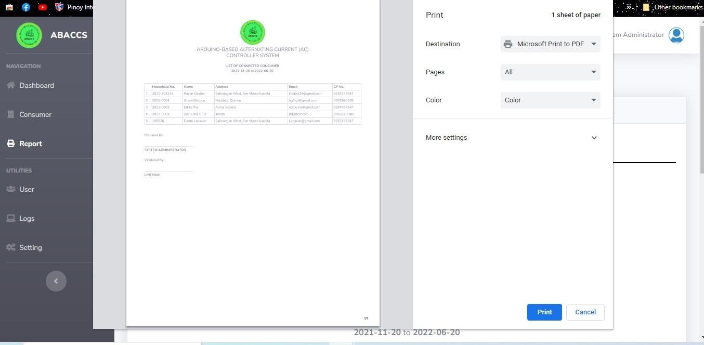

**Input/Output:** All the inputted information of the consumer of Iselco 1 would be recorded and generated a report for disconnection and reconnection.

**Appendix C**

## User’s guidelines

**USER GUIDE**

**A.** Disconnection head of Iselco 1. Open your browser in any devices and open the link below: **http://www.abaccs.com/**

Login

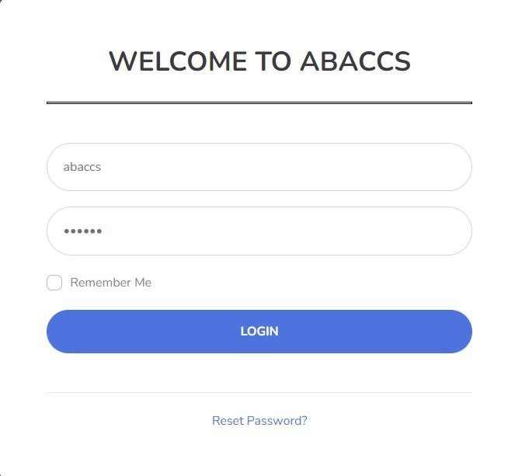

1



3



4



2

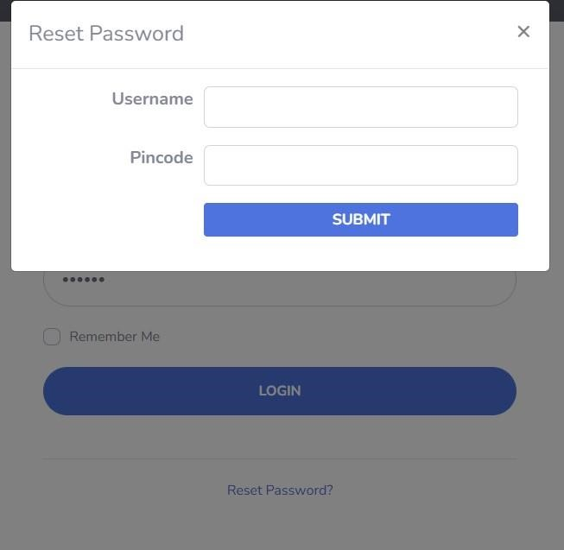

5



6



1. Default username of the administrator.
2. Default password of the administrator.
3. Check box to remember the username and password.
4. Once password is forgotten click reset password.
5. Enter the username of administrator
6. Enter the pin code of administrator

Dashboard

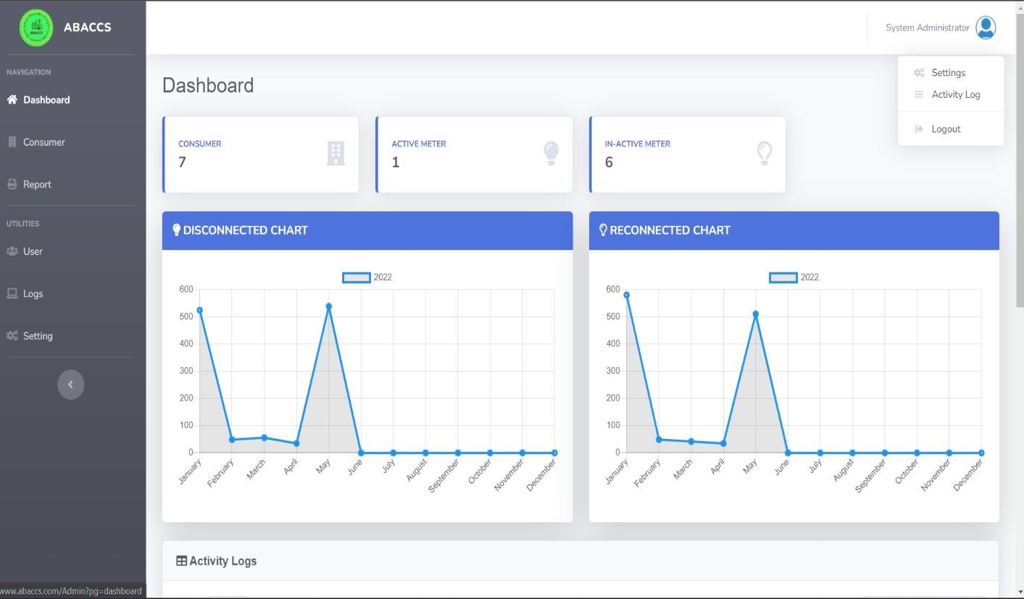

1



2



3



4



5



1. Total consumers of Iselco 1.
2. Total Active-meter of a consumer.
3. Total in Active-meter of a consumer.
4. 4 Graphical representations of disconnected and reconnected.
5. 5 List of activity of admin n the abaccs website.

Consumer

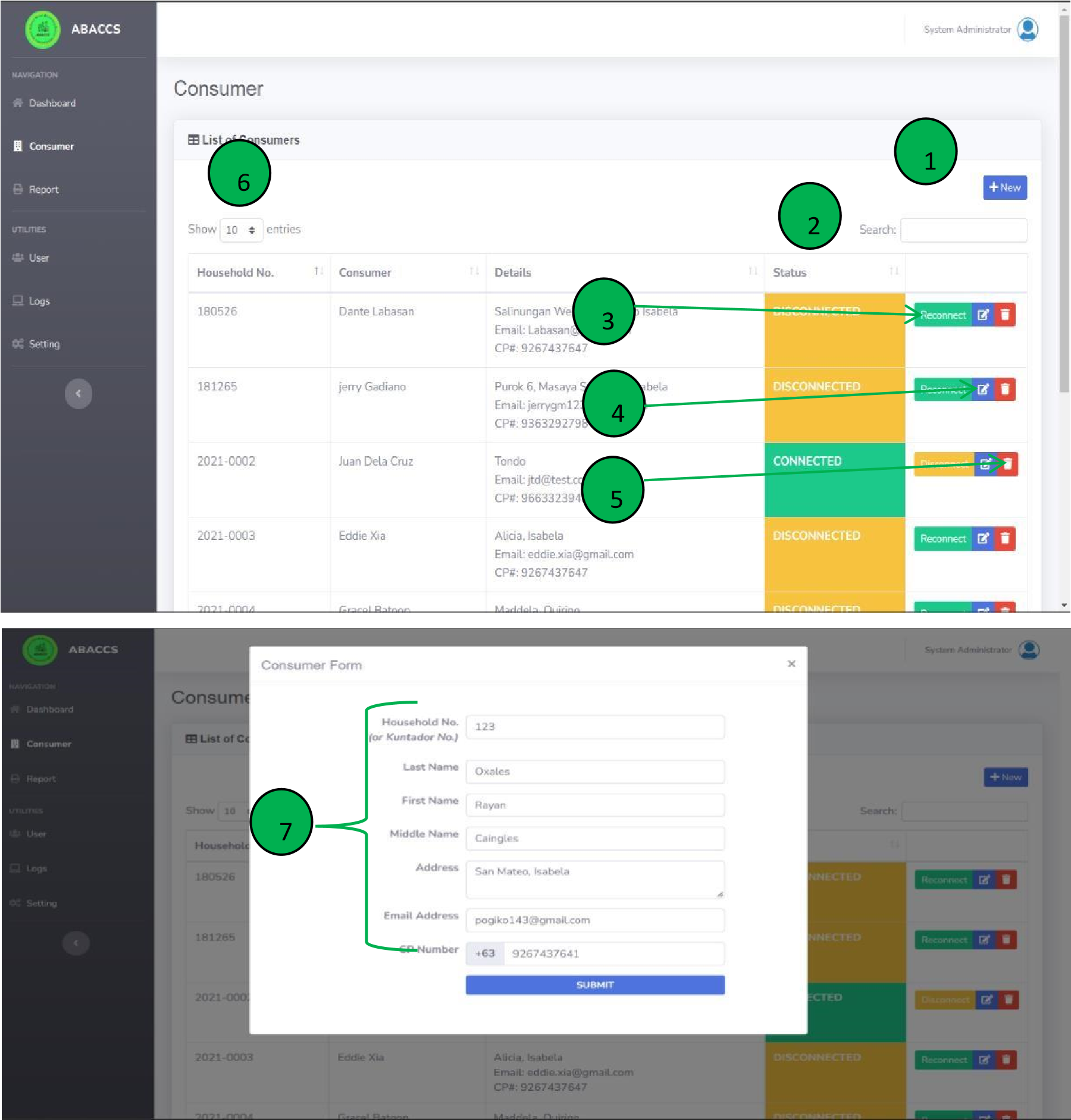

1. Add new consumer.
2. Search consumer by name and address.
3. Disconnect and reconnect consumer.
4. Edit the basic information of the consumer such as: last name, first name, middle name, address, email address and phone number.
5. Delete the consumer in the list.
6. Set the show entries.
7. Add new consumer by fill-up the consumer form.

Report

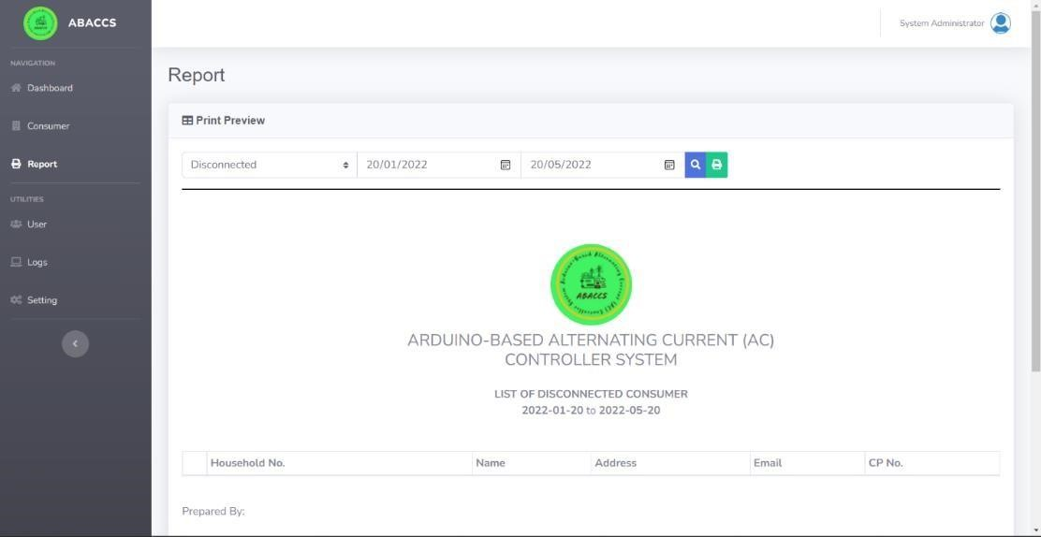

1



2



3



4



* 1. Select the status disconnected or reconnected.
  2. Set the date from (date) to (date) weekly, monthly and annually.
  3. Search the result of inputted information.
  4. Print the result of inputted information.

User

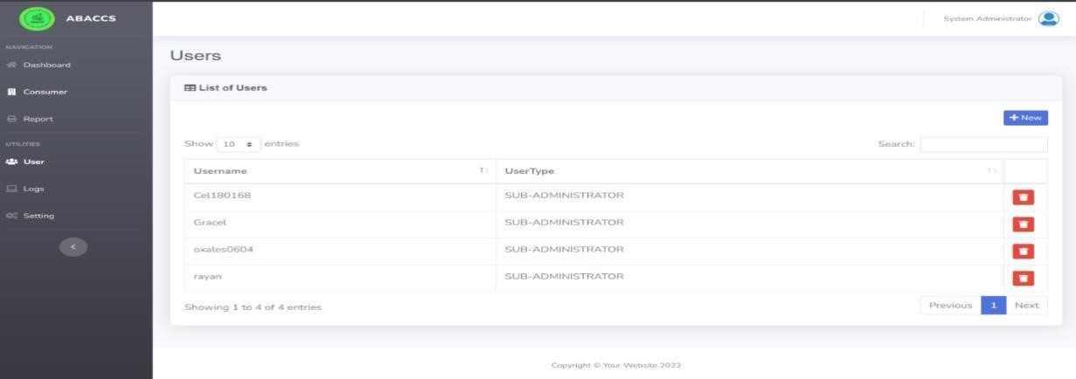

3



2



1



4

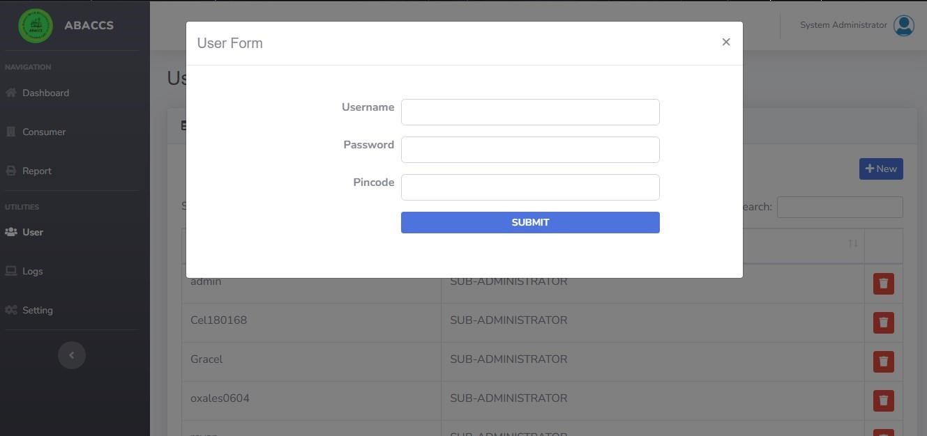

5



* 1. Add new users to manage the system
  2. Search for users.
  3. Delete the user from the list.
  4. Set the show entries.
  5. Add new user by completing the need information such as: username, password and pin code

Logs

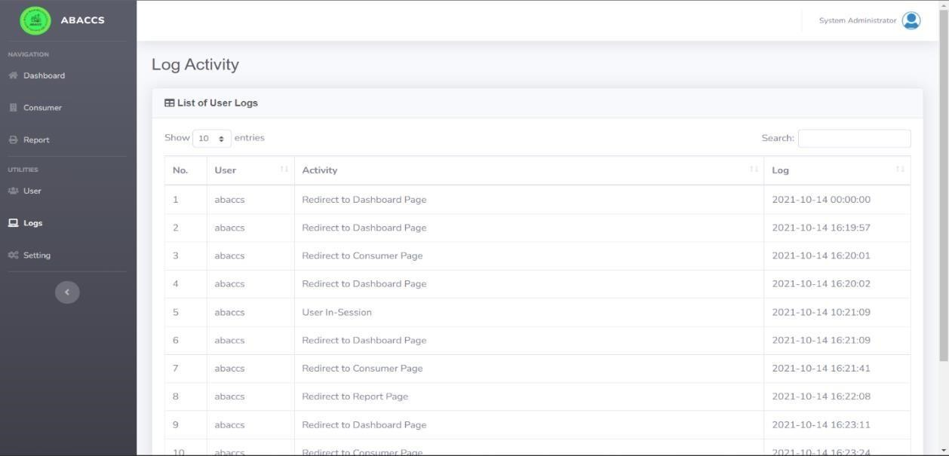

1



2



* 1. Set the show entries.
  2. Search activity logs by date and time.

Setting

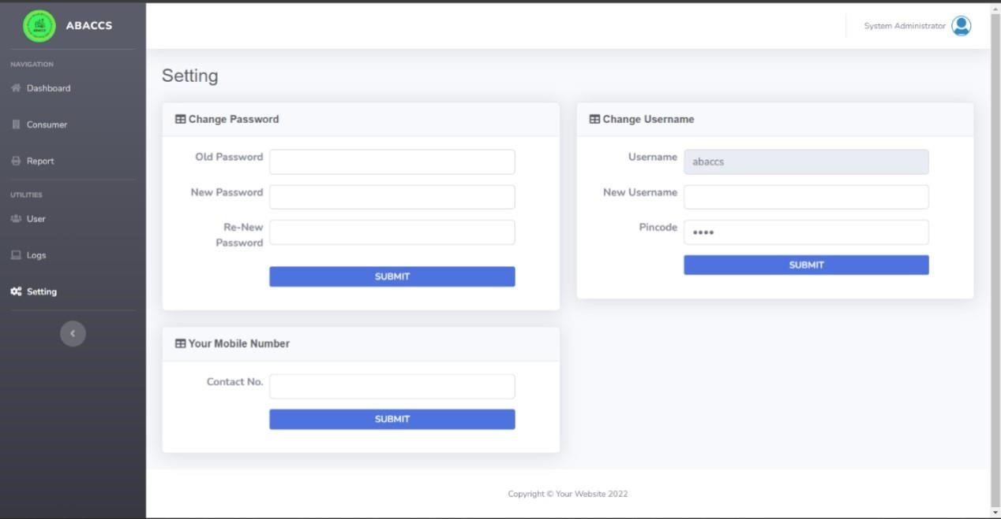

3



2



1



* 1. Change password create a new strongly password.
  2. Change username create a new unique username.
  3. Change mobile number for information contact.

Abaccs device

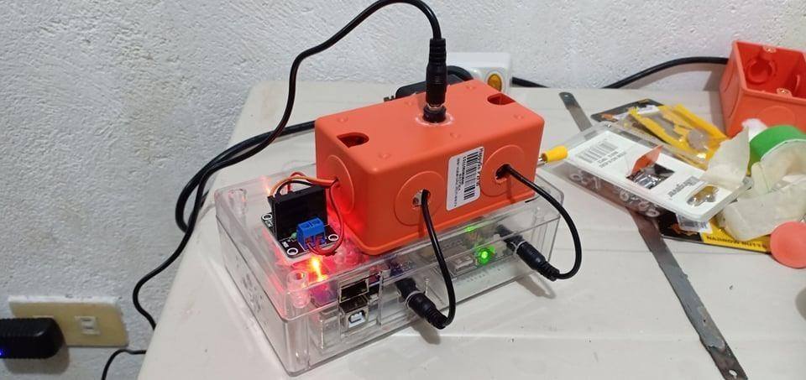

3



2



1



5



4



* 1. Power supply plug the adopter to fully power the device.
  2. Serial port to flash a new update code.
  3. LAN port to connect an internet cable with a RJ45 to have internet connection the device.
  4. Plug in these 2 wires before plug the main power supply
  5. Connection of the contactor into the device by using an extension wire.

Abaccs actual setup

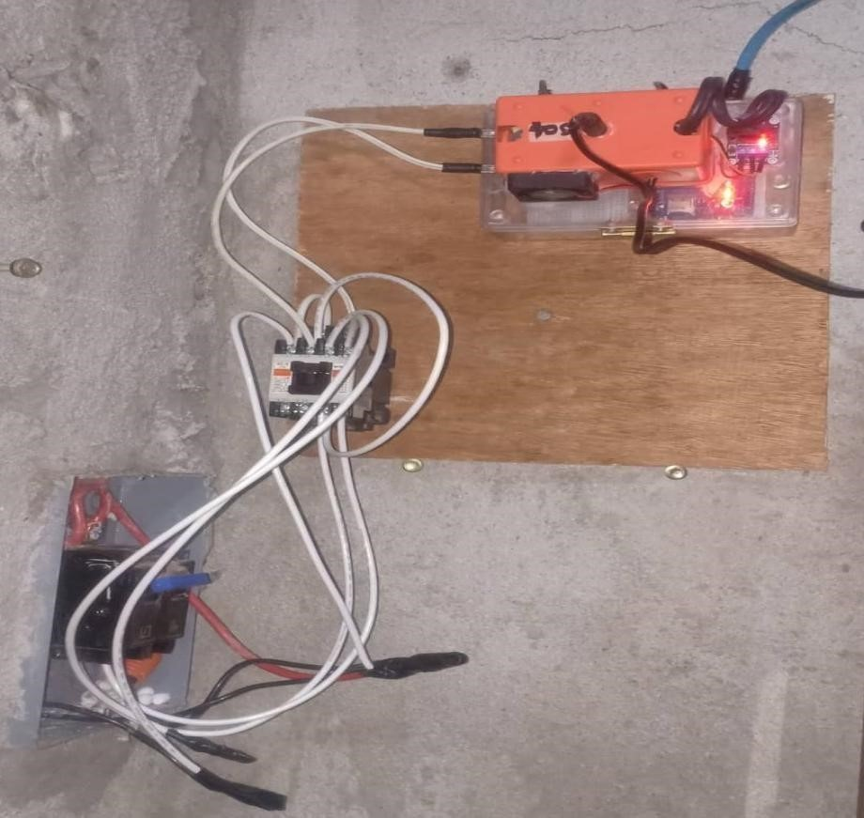

1



3



4



2



6



5



* 1. Abaccs device already set up the internet connection, power supply and a contactor.
  2. Two (2) wires connected to device and contactor (AC connection). In this wire will be the signal to trigger the contactor to on and off.
  3. Connect the two (2) wires into circuit breaker it will be the output of electricity 4. Connect the two (2) wires into circuit breaker to contactor for the output of electricity.
  4. The wire that connects to the contactor are the output of electricity of a household.
  5. The wire that connects to the contactor are the input of electricity to be controlled.

Appendix D

## Other Relevant Documents

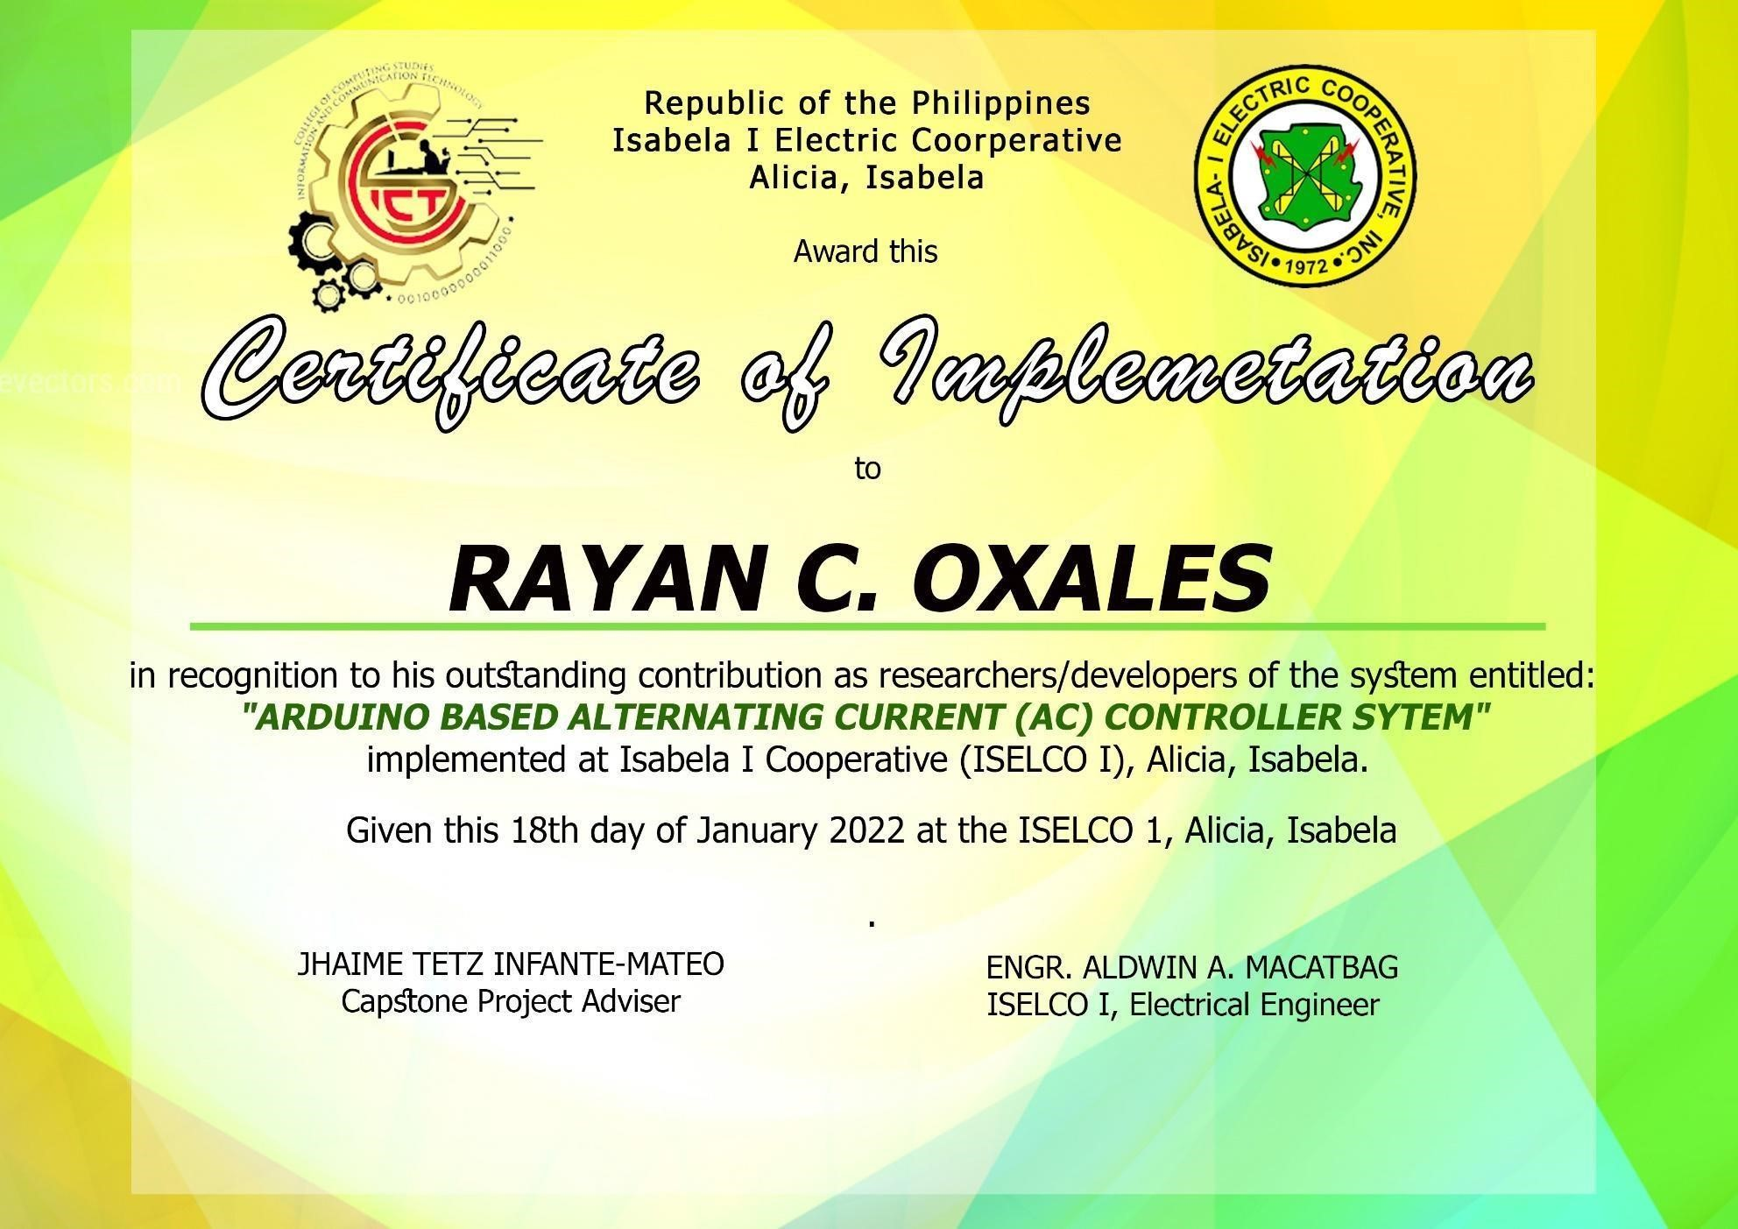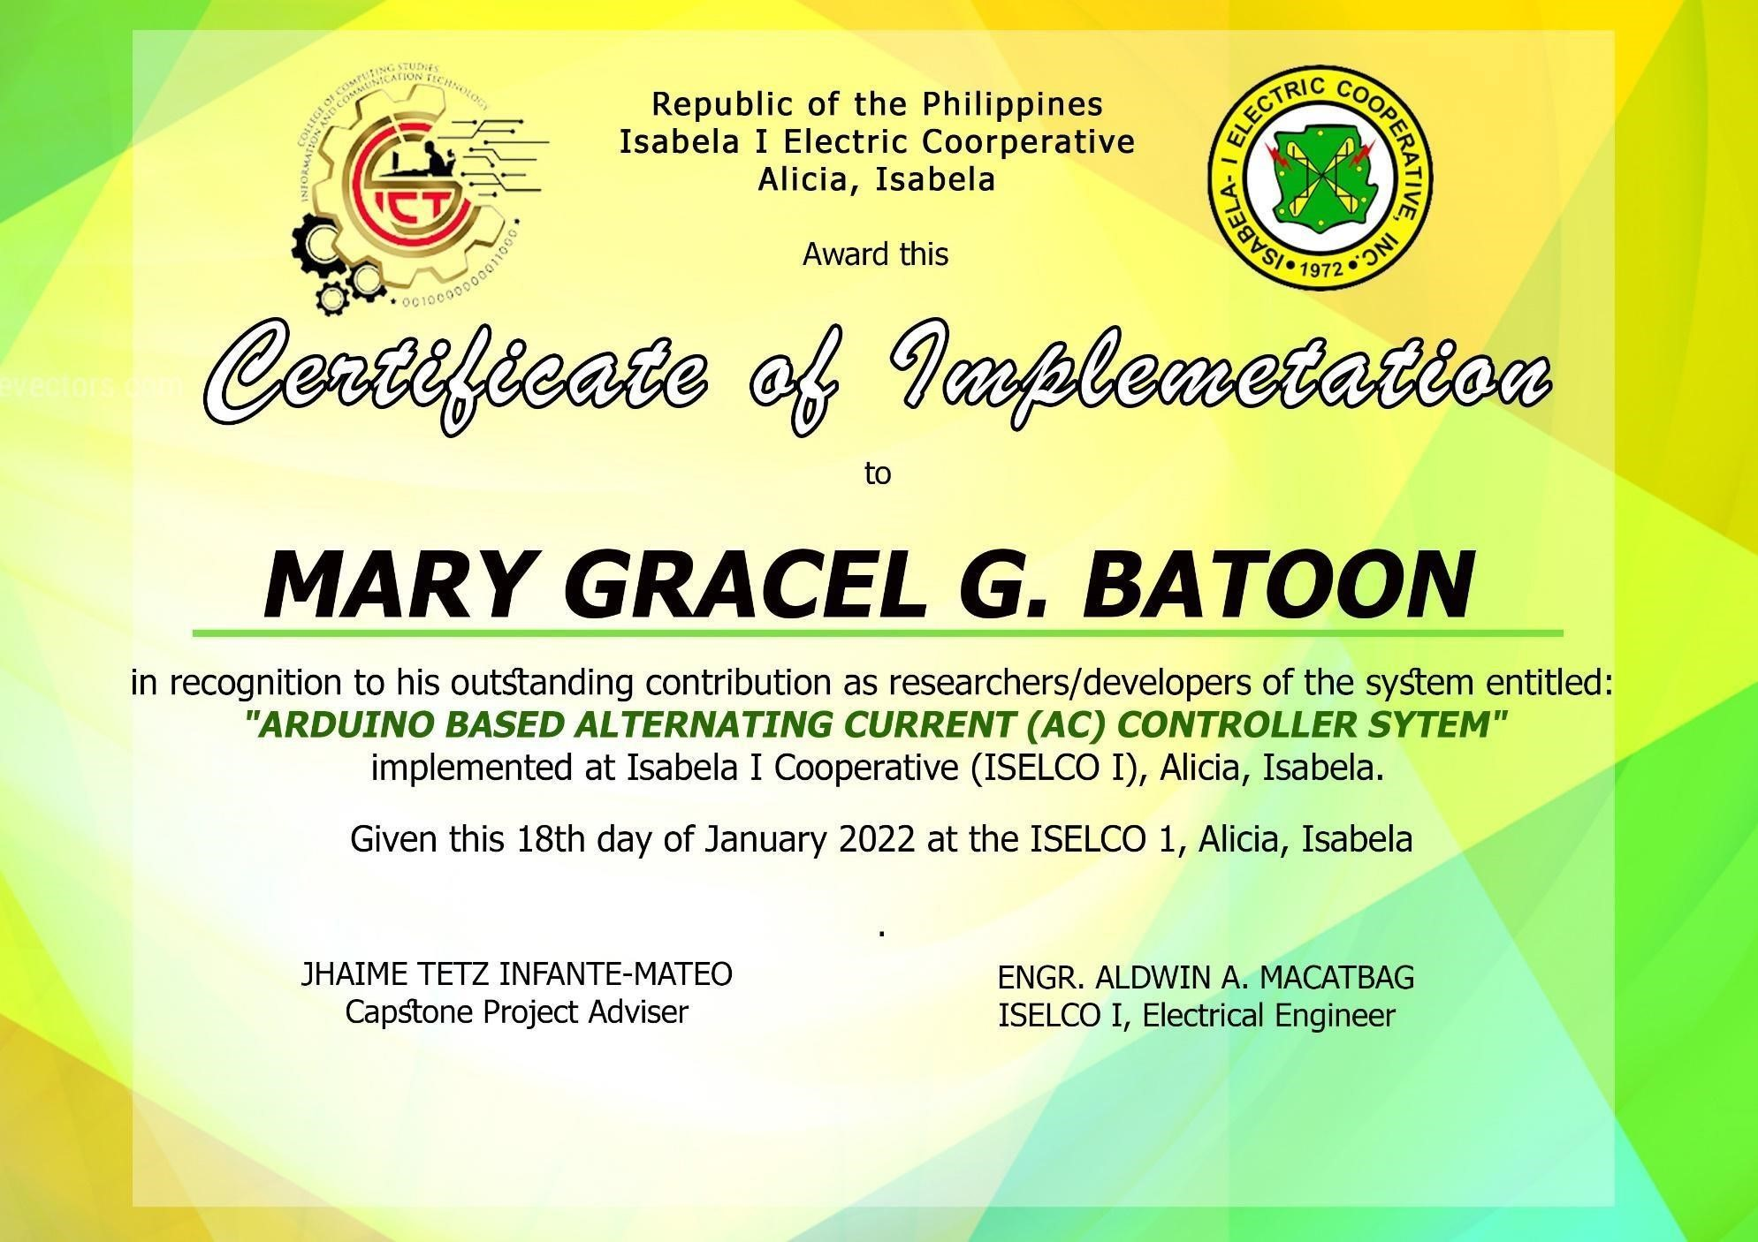

Appendix E

## Grammarian Certificate

G R A M M A R I A N’ S C E R T I F I C A T E

This is to certify that the undersigned has reviewed and went through all the pages of the thesis entitled **“ARDUINO-BASED ALTERNATING CURRENT (AC)**

**CONTROLLER SYSTEM”** of Rayan C. Oxales and Mary Gracel G. Batoon as against the set of structural rules that govern the composition of sentences, phrases, and words in English Language.

This certificate is issued upon the request of the names appeared above for any legal it may serve them.

Signed:

_______________________ English

Critic Position:

_______________________ ID

Number:

_______________________

_______________________ Contact

Details:

_______________________

_______________________

Conformed:

**JHAMIE TETZ INFANTE-MATEO, MSIT, MDM, DM**

Project Adviser

## Appendix F Gallery

### Gallery

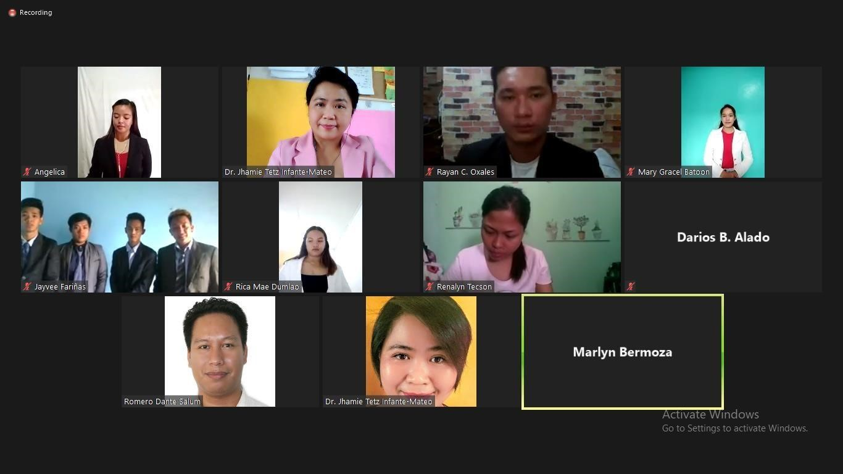

This screenshot was taken during Pre-proposal defense.

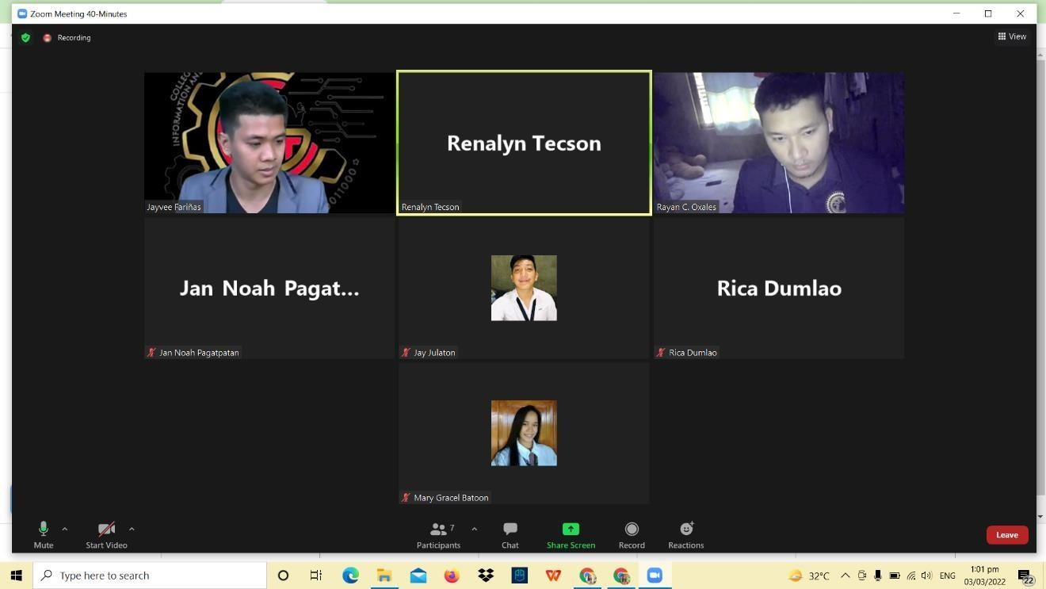

This screenshot was taken during system defense.

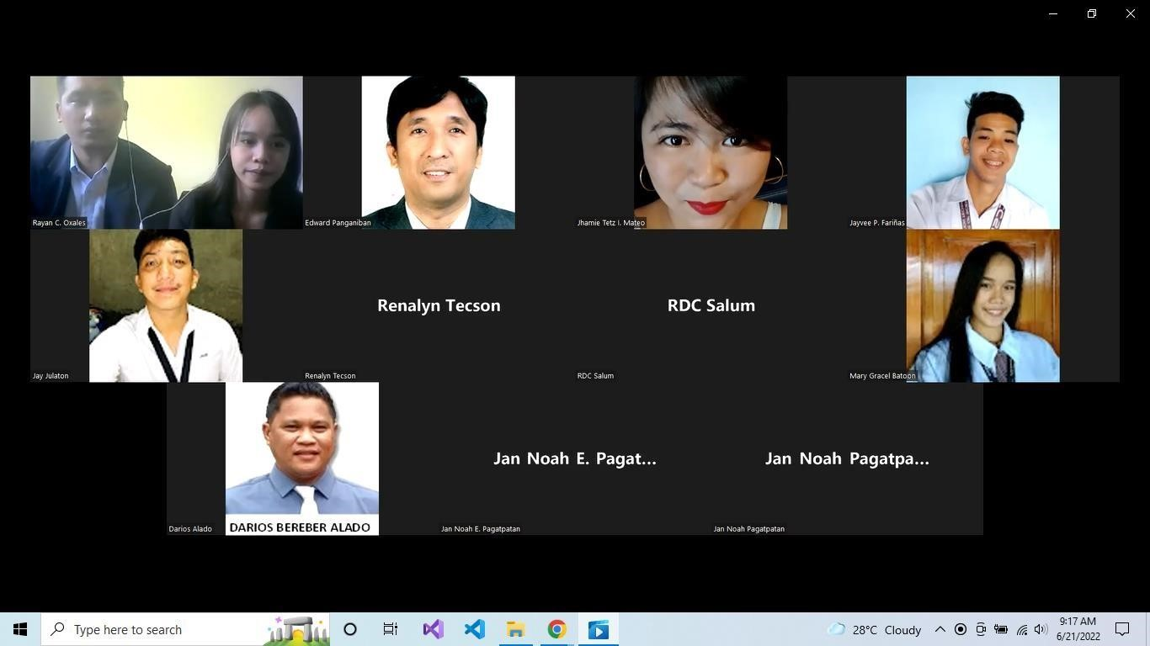

This screenshot was taken during manuscript defense.

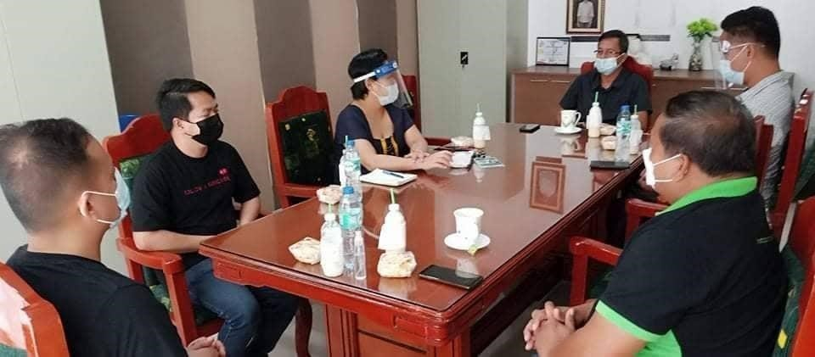

These shows the conducted interview to ISELCO1, Alicia, Isabella to improve the develop system and to know how the process of cutting of electricity.

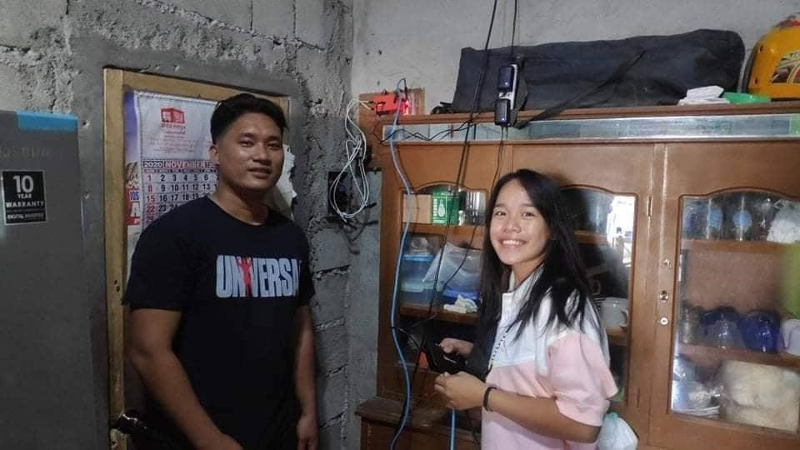

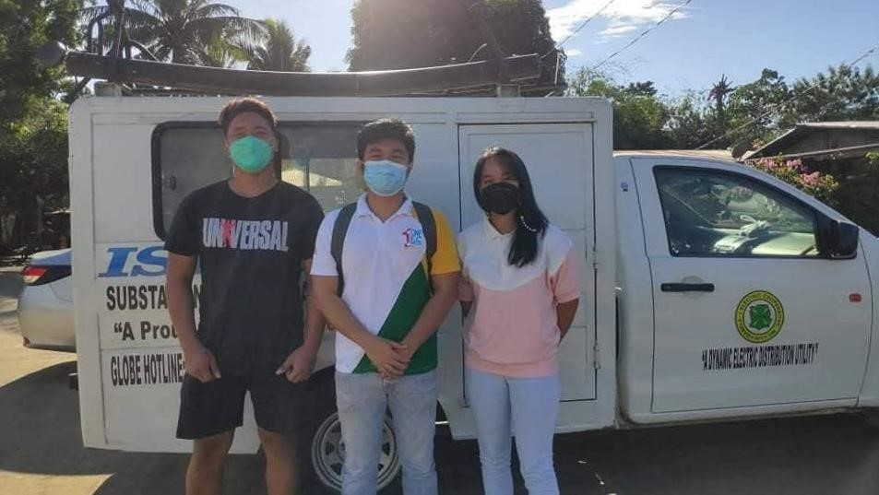

The Installation of the device was conducted face-to-face together with Eng.

Aldwin Macatbag an Electrical engineer of ISELCO 1 Alicia, Isabela.

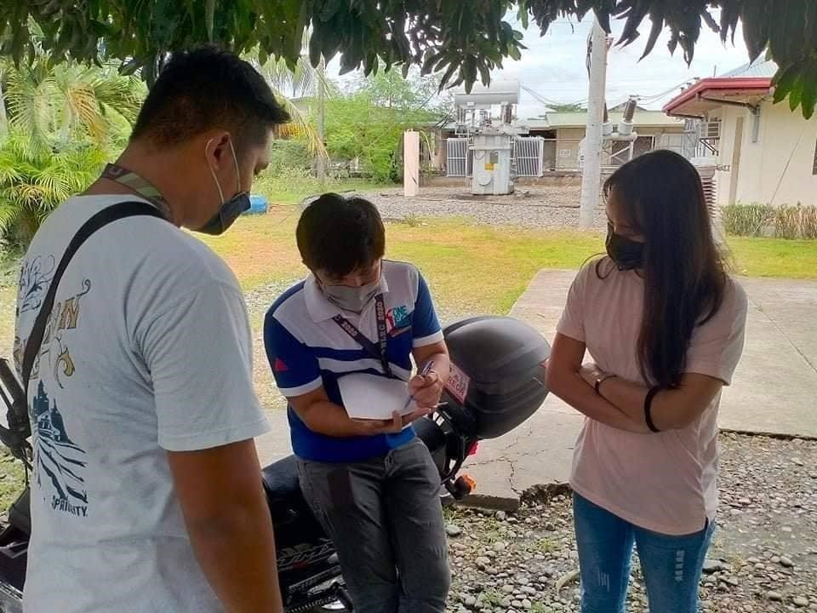

Consulting Eng. Aldwin Macatbag for the recommendation and how the internet connectivity of the device.

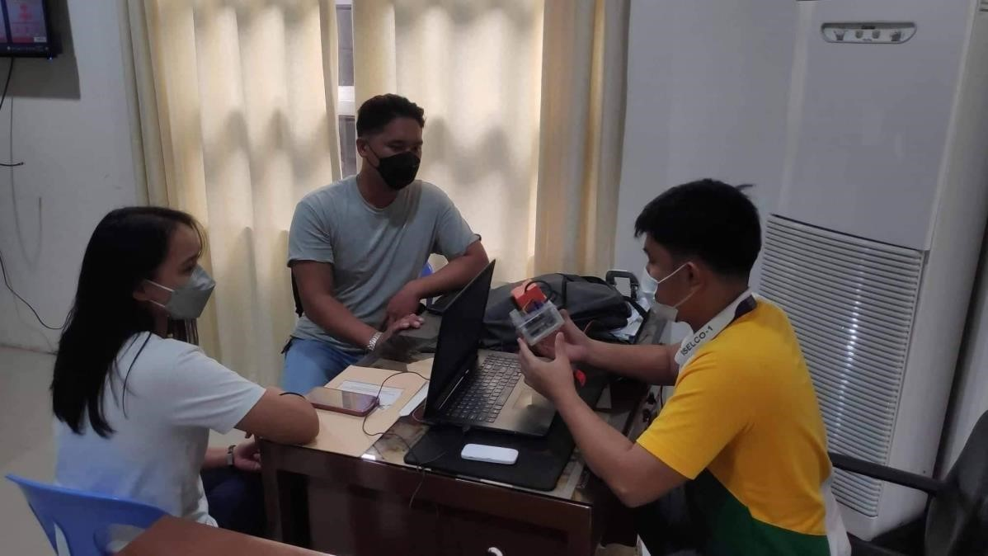

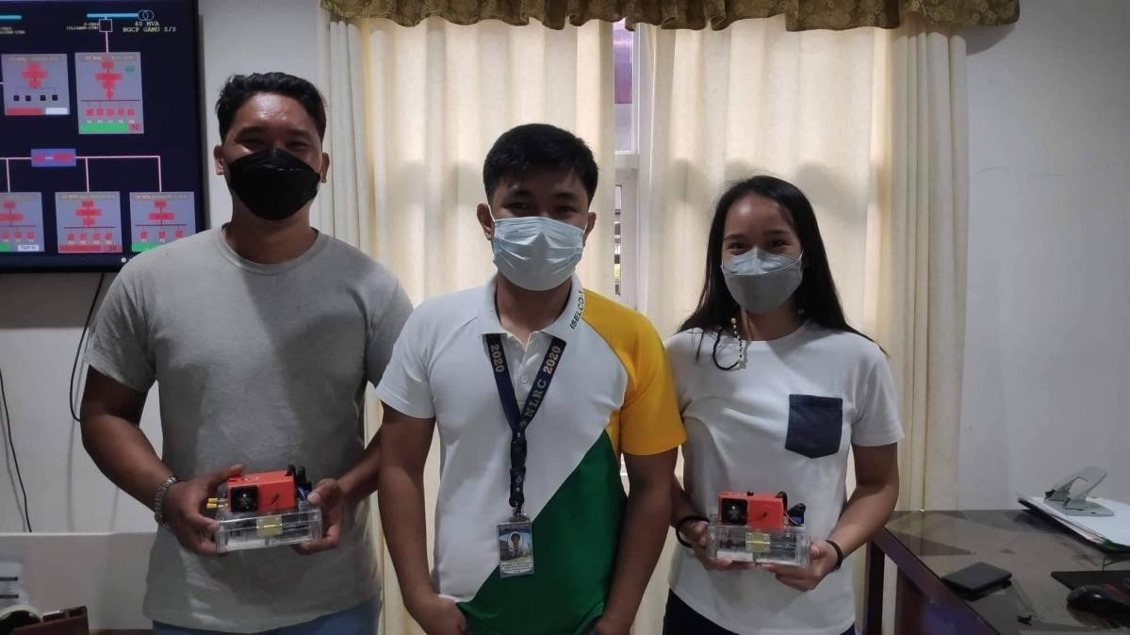

These show the user testing that conducted face-to-face at ISELCO 1 Alicia, Isabela. The researchers demonstrated the system and the head of disconnection helped to test the device and provided suggestions and information for the improvement of the system.

**‘**

## Appendix G Evaluation Tools

### Arduino Based Alternating Current Control System. (ABACCS)

Questionnaire For ISO 25010: Software Quality Standards

Using the scale below evaluate Arduino Based Alternating Current Controller System. by placing the mark on the appropriate column. Numeric Value Equivalent Rating (5- Strongly Agree, 4- Agree, 3-Undecided, 2-Disagree, 1- Strongly Disagree). How does the developed system comply with the ISO 25010 software quality standards in terms of the following factors?



5



4



3



2



1



### A. Functional Suitability

Functional Correctness. The system provides the correct results



with the needed degree of precision.

Functional Appropriateness. The system facilitates the

accomplishment of specified tasks and objectives.

Functional Completeness. The

system covers all the specified



tasks and user objectives.

### B. Usability

Appropriateness

Recognizability. The system allows



users to recognize if it is appropriate for their needs.

Learnability. The system can be used by specified users to achieve specified goals of learning to use the application with effectiveness, efficiency, freedom from risk and satisfaction in a specified context of use.



Operability. The system has attributes that make it easy to operate and control.



User Error Protection. The



system protects users against making errors.

User Interaction Aesthetics.

The system’s user interface enables

pleasing and satisfying interaction for the user.

Accessibility. The system can be used by people with the widest range of characteristics



and

capabilities to achieve a specified goal in a specified context of use.

### C. Reliability

Maturity. The system

meets the needs for reliability under normal  operation.

Availability. The system is

operational and accessible when required for use.

Fault Tolerance. The system operates as intended despite the

presence of hardware or

software faults.

the data directly affected Recoverability. The system can recover and re -establish the desired state.

### D. Security

Confidentiality. The system ensures that data are accessible only to those authorized to have access.



Integrity. The system

prevents unauthorized access to, or



modification of, computer programs or data.

Non-repudiation. The system can be proven to have taken place, so that the events or actions cannot be repudiated later.



### E. Maintainability

Modularity. The system is

composed of discrete



components such the change to one component has minimal impact on other components.

Reusability. An asset can be used in more than one system or in building other asset Analyzability. it is possible to assess the impact on the system of an intended change to one or more of its part, or to diagnose a product



for causes of failures, or to identify parts to be modified.

Modifiability. The system can be effectively and efficiently modified without

introducing defects or degrading existing



product quality

Testability. Test criteria can be established for a system and test can

be performed to determine whether



those criteria have been met.

Appendix H Curriculum Vitae

### Name: Rayan C. Oxales

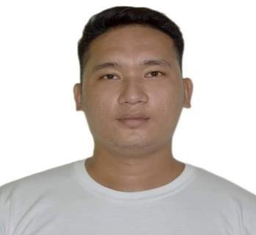

Contact: 09267437647

Email: jnay.e014@gmail.com

Personal Information

Nationality: Filipino

Civil Status: Single Date of Birth: June 04, 1997

Place of Birth: Guinobatan, Albay

Religion: Roman Catholic

Mother’s Name: Ginalyn C. Oxales Occupation:

Housewife

Father’s Name: Occupation:

Educational Background

University: Isabela State University

Course: Bachelor of Science in Information System

Address: San Fabian, Echague, Isabela

High School

Junior High: Eveland Christian College

Address: San Mateo, Isabela

Senior High: Eveland Christian College

|  |  |
| --- | --- |
| Strand: | ICT |
| Address: | San Mateo, Isabela |
| Elementary: | East Central School |
| Address: | San Mateo, Isabela |
| **Name:** | **Mary Gracel G. Batoon** |
| Contact: | 09502986539 |
| Email: | grace.celbatoon@gmail.com |

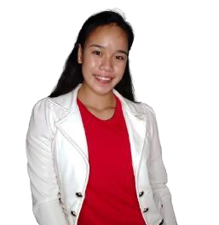

Personal Information

Nationality: Filipino

Civil Status: Single

Date of Birth: January 22, 2000

Place of Birth: San Maarcos, Cabarroguis, Quirino Religion: Roman Catholic

Mother’s Name: Mila Flor Batoon Occupation:

Housewife

Father’s Name: Maylo Batoon

Occupation: Driver

Educational Background

University: Isabela State University

Course: Bachelor of Science in Information System

Address: San Fabian, Echague, Isabela

High School

Junior High: Maddela Comprehensive High School

Address: Maddela, Quirino

Senior High: Maddela Comprehensive High School

Strand: Science, Technology, Engineering and Mathematics

Address: Maddela, Quirino

Elementary: Maddela North Central School Address:

Maddela, Quirino

### Glossary

**Arduino Uno.** The Arduino UNO is a standard board of Arduino. Here UNO means 'one' in Italian. It was named as UNO to label the first release of Arduino Software. It was also the first

USB board released by Arduino. It is considered as the powerful board used in various projects. Arduino.cc developed the Arduino UNO board. (Arduino UNO – JavaTpoint)

**Cross Platform.** A cross-platform computer product or system is one that can operate on multiple platforms or operating environments. (Techopedia, 2005)

**Database.** A methodical collection of data They enable electronic data storage and manipulation.

Databases simplify data management. (R. Peterson, 2022).

**Data Flow Diagram.** provide a simple, efficient method for organizations to comprehend, perfect, and implement new processes or systems Because they are visual representations of your process or system, they are simple to understand and prune. (Chi.C, 2021).

**Entity Relationship Diagram.** a data modeling technique that graphically depicts the entities and relationships of an information system. An entity framework data model (ERD) is a conceptual and representational data model used to represent the entity framework infrastructure.

(Techopedia, 2017).

**Ethernet Shield**. The **Arduino Ethernet Shield** allows an Arduino board to connect to the internet using the ethernet library and to read and write an SD card using the Sd library. This shield is fully compatible with the former version but relies on the newer W5500 chip. (Getting

Started with the Arduino Ethernet Shield.)

**Causal loop.** snapshot of all relationships that matter It is a visual representation of key variables (i.e., factors, issues, processes) and how they are interconnected. These diagrams show variables represented as texts and causal relationships between them represented as arrows.

**Contactor.** A **contactor** is an electrically controlled switch used for switching an electrical power circuit. A contactor is typically controlled by a circuit which has a much lower power level than the switched circuit, such as a 24-volt coil electromagnet controlling a 230-volt motor switch. (Hein Moeller 1890s)

**Functional Decomposition Diagram.** a method of dissecting a complex process in order to examine its individual components in this context, a function is a task within a larger process that is decomposed into smaller, more understandable units. (A. Hayes, 2021).

**Gantt Chart.** a common graphical representation of a project schedule It's a type of bar chart that displays the start and end dates of project elements like resources, planning, and dependencies.

(M.Grant, 2021).

**Input-Process-Output (IPO).** a structured methodology for recording and visualizing all the inputs, outputs, and process steps required to convert inputs into outputs It is frequently referred to as an I-P-O model or an I-P-O diagram, both of which refer to the method's intended visual nature. (iSixSigma, 2021).

**Methodology.** a set of methods and principles for doing something, such as teaching or conducting research. (Collins Dictionary, 2022).

**One Time Password.** a one-time, secure PIN code sent to you via SMS or email that is only valid for one session Smart-ID uses OTPs to confirm your contact information during registration and account renewal. (Smart.ID, 2021).

**Rapid Development Methodology.** a method of Agile software development that emphasizes rapid prototype releases and iterations. Unlike the Waterfall method, the RAD model prioritizes software and user feedback over strict planning and requirement documentation (T. Cox, 2019).  **Short Message Service (SMS).** is the most fundamental mobile data transfer communications technology, characterized by the exchange of short alphanumeric text messages between digital lines and mobile devices. The affordability of SMS messaging is the most influential factor.

(Techopedia, 2019).

**Solid State relay**. A solid state relay (SSR) is an [electronic switching device t](https://en.wikipedia.org/wiki/Electronic_switch)hat switches on or off when an external [voltage (](https://en.wikipedia.org/wiki/Voltage)AC or DC) is applied across its control terminals. They serve the same function as an [electromechanical relay,](https://en.wikipedia.org/wiki/Electromechanical_relay) but as [solid-state electronics c](https://en.wikipedia.org/wiki/Solid-state_electronics)ontain no [moving parts a](https://en.wikipedia.org/wiki/Moving_parts)nd have a longer operational lifetime.(Crydom engineers in 1972 )

### COST BENEFIT ANALYSIS (ESTIMATES)

